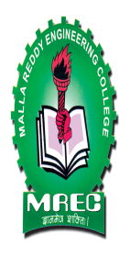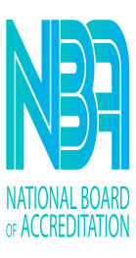 | MALLA REDDY ENGINEERING COLLEGE (Autonomous)  ( An Autonomous Institution approved by UGC and Affiliated to JNTU Hyderabad, Accredited by NACC with ‘A++’ Grade, Accredited by NBA, Maisammaguda, Dhulapally, (Post,Via Kompally), Secunderabad – 500100 Ph:040-64634234). | 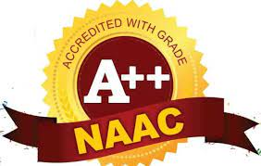

Name of the Lab: | M.Tech Labs (PG)  i). Advanced Data Structures Lab  ii). Data Science Lab  iii). Advanced Algorithms Lab  iv). Deep Learning Lab
Lab In-charge: | Ms. G. Prathibha / Ms. Nagama Begum
Lab Location: | 401
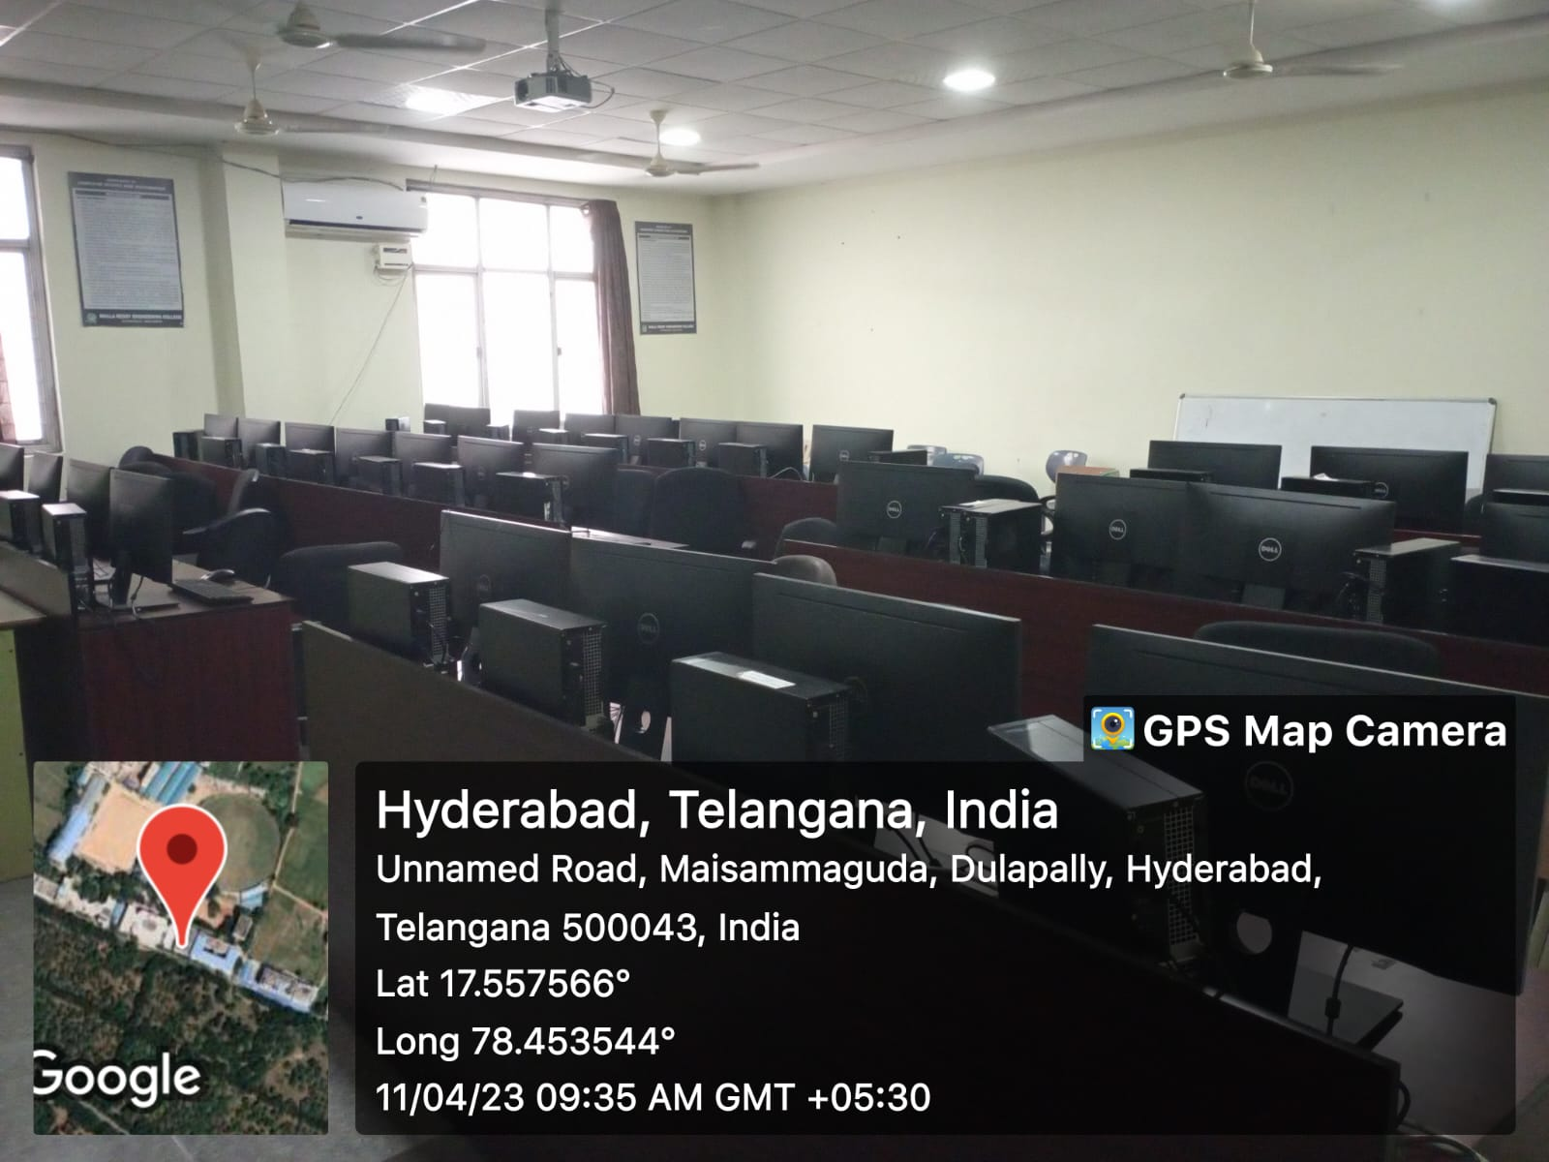
M.Tech LAB

