COMPUTER ORGANIZATION

Syllabus

Unit-1
Basic Computer Organization –Functions of CPU,I/O Units, Memory Instructions: Instruction Formats- One Address, two Address, Zero Address and Three Addresses and comparison; Addresing Modes with numerical examples: program Control-status bit conditions, conditional branch instructions, Program interrupts: Types of Interrupts.

Unit-II
Input-Output Organizations-I/O Interface,I/O Bus and Interface Modules:
I/O Vs memory Bus, Isolated Vs Memory -Mapped I/O, Asynchronous data transfer –Strobe Control, hand Shaking: Asynchronous Serial Transfer- Asynchronous Communication Interface, Modes of transfer-Programmed I/O, Interrupt Initiated I/O,DMA:DMA Controller, Transfer, IOP-CPU-IOP Communication, Intel 8089 IOP

Unit-III
Memory Organizations
Memory Hierarchy, Main Memory, RAM,ROM Chips, Memory Address Map, Memory Connection to CPU, Associate Memory , Cache Memory, Data Cache, Instruction Cache, Miss and Hit ratio, Access time, associative, set associative, mapping, waiting into cache, introduction to virtual memory

Unit-IV
8086 CPU Pin Diagram-Special functions of general purpose registers, segment register, concept of pipelining,8086Flag register, Addressing modes of 8086

Unit-V
8086 Instruction formats:
Assembly Language programs involving branch& Call instructions, sorting, evaluation of arithmetic expressions

Detailed Notes

Unit-I

Basic Structure of Computers
Computer Architecture in general covers three aspects of computer design namely: Computer Hardware, Instruction set Architecture and Computer Organization.
Computer hardware consists of electronic circuits, displays, magnetic and optical storage media and communication facilities.
Instruction set Architecture is programmer visible machine interface such as instruction set, registers, memory organization and exception handling. Two main approaches are mainly CISC (Complex Instruction Set Computer) and RISC (Reduced Instruction Set Computer)
Computer Organization includes the high level aspects of a design, such as memory system, the bus structure and the design of the internal CPU.

Computer Types

Computer is a fast electronic calculating machine which accepts digital input, processes it according to the internally stored instructions (Programs) and produces the result on the output device. The internal operation of the computer can be as depicted in the figure below:

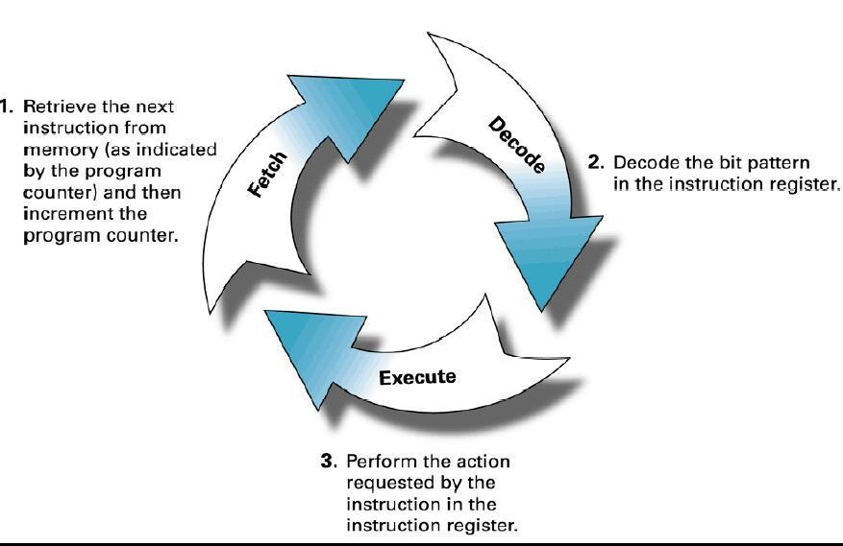

Figure 1: Fetch, Decode and Execute steps in a Computer System

The computers can be classified into various categories as given below:

  - Micro Computer

  - Laptop Computer

  - Work Station

  - Super Computer

  - Main Frame

  - Hand Held

  - Multi core

Micro Computer: A personal computer; designed to meet the computer needs of an individual. Provides access to a wide variety of computing applications, such as word processing, photo editing, e-mail, and internet.

Laptop Computer: A portable, compact computer that can run on power supply or a battery unit. All components are integrated as one compact unit. It is generally more expensive than a comparable desktop. It is also called a Notebook.

Work Station: Powerful desktop computer designed for specialized tasks. Generally used for tasks that requires a lot of processing speed. Can also be an ordinary personal computer attached to a LAN (local area network).

Super Computer: A computer that is considered to be fastest in the world. Used to execute tasks that would take lot of time for other computers. For Ex: Modeling weather systems, genome sequence, etc (Refer site: http://www.top500.org/)

Main Frame: Large expensive computer capable of simultaneously processing data for hundreds or thousands of users. Used to store, manage, and process large amounts of data that need to be reliable, secure, and centralized.

Hand Held: It is also called a PDA (Personal Digital Assistant). A computer that fits into a pocket, runs on batteries, and is used while holding the unit in your hand. Typically used as an appointment book, address book, calculator and notepad.

Multi Core: Have Multiple Cores – parallel computing platforms. Many Cores or computing elements in a single chip. Typical Examples: Sony Play station, Core2Duo,i3,i7etc

Functional Unit

A computer in its simplest form comprises five functional units namely input unit, output unit memory unit, arithmetic & logic unit and control unit. Figure 2 depicts the functional units of a computer system.
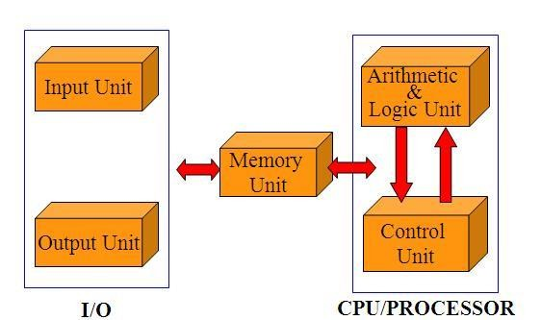

Figure 2: Basic functional units of a computer

Let us discuss about each of them in brief:

- Input Unit: Computer accepts encoded information through input unit. The standard input device is a keyboard. Whenever a key is pressed, keyboard controller sends the code to CPU/Memory.
Examples include Mouse, Joystick, Tracker ball, Light pen, Digitizer, Scanner etc.

- Memory Unit: Memory unit stores the program instructions (Code), data and results of computations etc. Memory unit is classified as:

  - Primary /Main Memory

  - Secondary
  - Memory/Auxiliary

Primary memory is a semiconductor memory that provides access at high speed. Run time program instructions and operands are stored in the main memory. Main memory is classified again as ROM and RAM. ROM holds system programs and firmware routines such as BIOS, POST, I/O Drivers that are essential to manage the hardware of a computer. RAM is termed as Read/Write memory or user memory that holds run time program instruction and data. While primary storage is essential, it is volatile in nature and expensive. Additional requirement of memory could be supplied as auxiliary memory at cheaper cost. Secondary memories are non volatile in nature.

- Arithmetic and logic unit: ALU consist of necessary logic circuits like adder, comparator etc., to perform operations of addition, multiplication, comparison of two numbers etc.

- Output Unit: Computer after computation returns the computed results, error messages, etc. via output unit. The standard output device is a video monitor, LCD/TFT monitor. Other output devices are printers, plotters etc.

- Control Unit: Control unit co-ordinates activities of all units by issuing control signals. Control signals issued by control unit govern the data transfers and then appropriate operations take place. Control unit interprets or decides the operation/action to be performed.
The operations of a computer can be summarized as follows:

- A set of instructions called a program reside in the main memory of computer.

- The CPU fetches those instructions sequentially one-by-one from the main memory, decodes them and performs the specified operation on associated data operands in ALU.

- Processed data and results will be displayed on an output unit.

- All activities pertaining to processing and data movement inside the computer machine are governed by control unit.

Basic Operational Concepts

An Instruction consists of two parts, an Operation code and operand/s as shown below:
OPERAND/s
OPCODE

Let us see a typical instruction

ADD LOCA, R0

This instruction is an addition operation. The following are the steps to execute the instruction:

Step 1: Fetch the instruction from main memory into the processor
Step 2: Fetch the operand at location LOCA from main memory into the processor
Step 3: Add the memory operand (i.e. fetched contents of LOCA) to the contents of register
R0 Step 4: Store the result (sum) in R0.
The same instruction can be realized using two instructions as

Load LOCA, R1 Add R1, R0
The steps to execute the instructions can be enumerated as below:

Step 1: Fetch the instruction from main memory into the processor Step 2: Fetch the operand at location LOCA from main memory into
the processor Register R1
Step 3: Add the content of Register R1 and the contents of register R0 Step 4: Store the result (sum) in R0.

Figure 3 below shows how the memory and the processor are connected. As shown in the diagram, in addition to the ALU and the control circuitry, the processor contains a number of registers used for several different purposes. The instruction register holds the instruction that is currently being executed. The program counter keeps track of the execution of the program. It contains the memory address of the next instruction to be fetched and executed. There are n general purpose registers R0 to Rn-1 which can be used by the programmers during writing programs.

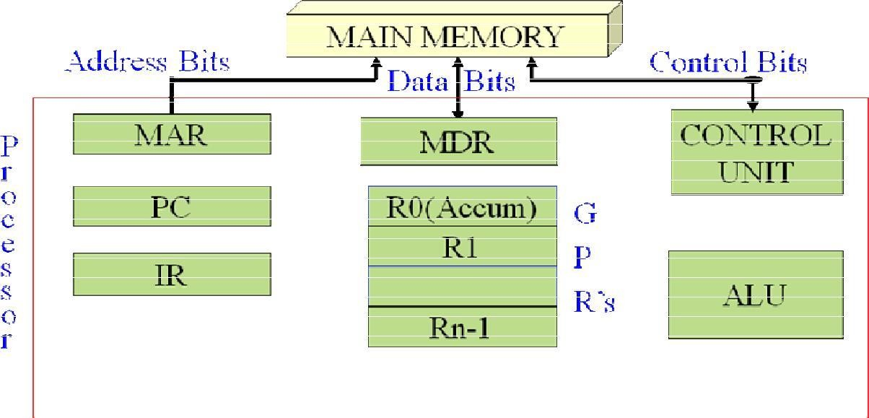

Figure 3: Connections between the processor and the memory

The interaction between the processor and the memory and the direction of flow of information is as shown in the diagram below:
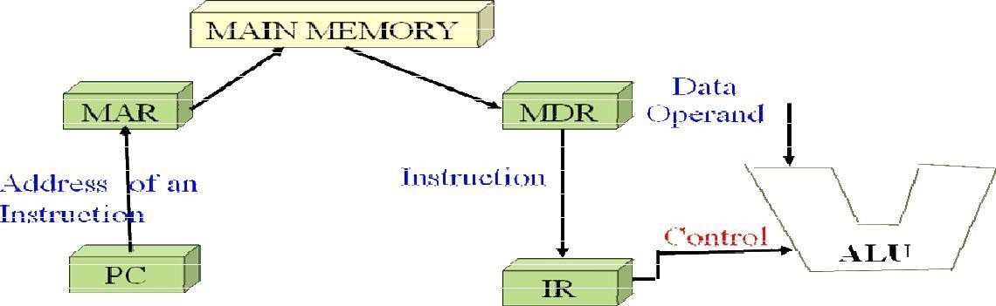

Figure 4: Interaction between the memory and

The most common fields found in instruction format are:-

- An operation code field that specified the operation to be performed
- An address field that designates a memory address or a processor registers.

- A mode field that specifies the way the operand or the effective address is determined.

Computers may have instructions of several different lengths containing varying number of addresses. The number of address field in the instruction format of a computer depends on the internal organization of its registers. Most computers fall into one of three types of CPU organization.

- Single Accumulator organization ADD X AC ® AC + M [×]
- General Register Organization ADD R1, R2, R3 R ® R2 + R3
- Stack Organization PUSH X

Three address Instruction

Computer with three addresses instruction format can use each address field to specify either processor register are memory operand.

ADD R1, A, B A1 ® M [A] + M [B]
ADD R2, C, D R2 ® M [C] + M [B] X = (A + B) * (C + A) MUL X, R1, R2 M [X] R1 * R2

The advantage of the three address formats is that it results in short program when evaluating arithmetic expression. The disadvantage is that the binary-coded instructions require too many bits to specify three addresses.

Two Address Instruction

Most common in commercial computers. Each address field can specify either a processes register on a memory word.

MOV | R1, A | R1 ® M [A]
ADD | R1, B | R1 ® R1 + M [B]
MOV | R2, C | R2 ® M [C] X = (A + B) * ( C + D)
ADD | R2, D | R2 ® R2 + M [D]
MUL | R1, R2 | R1 ® R1 * R2
MOV | X1 R1 | M [X] ® R1

One Address instruction

It used an implied accumulator (AC) register for all data manipulation. For multiplication/division, there is a need for a second register.

LOAD A AC ® M [A]
ADD B AC ® AC + M [B]
STORE T M [T] ® AC X = (A +B) × (C + A)

All operations are done between the AC register and a memory operand. It’s the address of a temporary memory location required for storing the intermediate result.

LOAD | C | AC ® M (C)
ADD | D | AC ® AC + M (D)
ML | T | AC ® AC + M (T)
STORE | X | M [×]® AC

Zero – Address Instruction

A stack organized computer does not use an address field for the instruction ADD and MUL. The PUSH & POP instruction, however, need an address field to specify the operand that communicates with the stack (TOS ® top of the stack)

PUSH | A | TOS ® A
PUSH | B | TOS ® B
ADD |  | TOS ® (A + B)
PUSH | C | TOS ® C
PUSH | D | TOS ® D
ADD |  | TOS ® (C + D)
MUL |  | TOS ® (C + D) * (A + B)
POP | X | M [X] TOS

CISC Characteristics

A computer with large number of instructions is called complex instruction set computer or CISC. Complex instruction set computer is mostly used in scientific computing applications requiring lots of floating point arithmetic.

  - A large number of instructions - typically from 100 to 250 instructions.
  - Some instructions that perform specialized tasks and are used infrequently.
  - A large variety of addressing modes - typically 5 to 20 different modes.
  - Variable-length instruction formats
  - Instructions that manipulate operands in memory.

RISC Characteristics

A computer with few instructions and simple construction is called reduced instruction set computer or RISC. RISC architecture is simple and efficient. The major characteristics of RISC architecture are,

- Relatively few instructions
- Relatively few addressing modes
- Memory access limited to load and store instructions
- All operations are done within the registers of the CPU
- Fixed-length and easily-decoded instruction format.
- Single cycle instruction execution
- Hardwired and micro programmed control

Addressing Modes

The operation field of an instruction specifies the operation to be performed. This operation must be executed on some data stored in computer register as memory words. The way the operands are chosen during program execution is dependent on the addressing mode of the instruction. The addressing mode specifies a rule for interpreting or modifying the address field of the instruction between the operand is activity referenced. Computer use addressing mode technique for the purpose of accommodating one or both of the following provisions.

  - To give programming versatility to the uses by providing such facilities as pointer to memory, counters for top control, indexing of data, and program relocation.
  - To reduce the number of bits in the addressing fields of the instruction.

The basic operation cycle of the computer

- Fetch the instruction from memory
- Decode the instruction
- Execute the instruction

Program Counter (PC) keeps track of the instruction in the program stored in memory. PC holds the address of the instruction to be executed next and in incremented each time an instruction is fetched from memory.

Addressing Modes: The most common addressing techniques are
- Immediate
- Direct
- Indirect
- Register
- Register Indirect
- Displacement
- Stack

All computer architectures provide more than one of these addressing modes. The question arises as to how the control unit can determine which addressing mode

is being used in a particular instruction. Several approaches are used. Often, different opcodes will use different addressing modes. Also, one or more bits in the instruction format can be used as a mode field. The value of the mode field determines which addressing mode is to be used.
What is the interpretation of effective address. In a system without virtual memory, the effective address will be either a main memory address or a register. In a virtual memory system, the effective address is a virtual address or a register. The actual mapping to a physical address is a function of the paging mechanism and is invisible to the programmer.

Opcode | Mode | Address

Immediate Addressing:
The simplest form of addressing is immediate addressing, in which the operand is actually present in the instruction:
OPERAND = A
This mode can be used to define and use constants or set initial values of variables. The advantage of immediate addressing is that no memory reference other than the instruction fetch is required to obtain the operand. The disadvantage is that the size of the number is restricted to the size of the address field, which, in most instruction sets, is small compared with the world length.
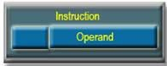

Direct Addressing:
A very simple form of addressing is direct addressing, in which the address field contains the effective address of the operand:
EA = A
It requires only one memory reference and no special calculation.
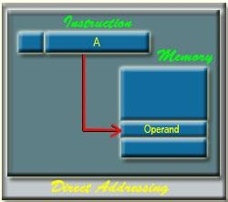

Indirect Addressing:

With direct addressing, the length of the address field is usually less than the word length, thus limiting the address range. One solution is to have the address
field refer to the address of a word in memory, which in turn contains a full-length address of the operand. This is know as indirect addressing:
EA = (A)
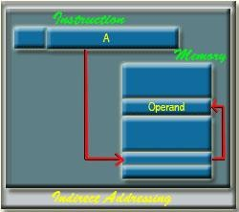

Register Addressing:
Register addressing is similar to direct addressing. The only difference is that the address field refers to a register rather than a main memory address:
EA = R
The advantages of register addressing are that only a small address field is needed in the instruction and no memory reference is required.
The disadvantage of register addressing is that the address space is very limited.
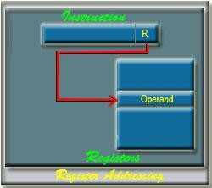

The exact register location of the operand in case of Register Addressing
Mode is shown in the Figure 34.4. Here, 'R' indicates a register where the operand is present.

Register Indirect Addressing:
Register indirect addressing is similar to indirect addressing, except that the address field refers to a register instead of a memory location. It requires only one memory reference and no special calculation.

EA = (R)
Register indirect addressing uses one less memory reference than indirect addressing. Because, the first information is available in a register which is nothing but a memory address. From that memory location, we use to get the data or information. In general, register access is much more faster than the memory access.
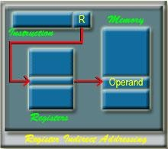

Displacement Addressing:
A very powerful mode of addressing combines the capabilities of direct addressing and register indirect addressing, which is broadly categorized as displacement addressing:
EA = A + (R)
Displacement addressing requires that the instruction have two address fields,
at least one of which is explicit. The value contained in one address field (value = A) is used directly. The other address field, or an implicit reference based on opcode, refers to a register whose contents are added to A to produce the effective address.
The general format of Displacement Addressing is shown in the Figure 4.6. Three of the most common use of displacement addressing are:
- Relative addressing
- Base-register addressing
- Indexing

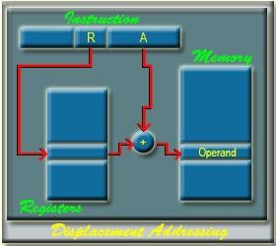

Relative Addressing:
For relative addressing, the implicitly referenced register is the program
counter (PC). That is, the current instruction address is added to the address field to produce the EA. Thus, the effective address is a displacement relative to the address of the instruction.

Base-Register Addressing:
The reference register contains a memory address, and the address field
contains a displacement from that address. The register reference may be explicit or implicit. In some implementation, a single segment/base register is employed and is used implicitly. In others, the programmer may choose a register to hold the base address of a segment, and the instruction must reference it explicitly.

Indexing:
The address field references a main memory address, and the reference
register contains a positive displacement from that address. In this case also the register reference is sometimes explicit and sometimes implicit.
Generally index register are used for iterative tasks, it is typical that there is a need to increment or decrement the index register after each reference to it.
Becausethis is such a common operation, some system will automatically do this as part of the same instruction cycle.
This is known as auto-indexing. We may get two types of auto-indexing: -one is auto-incrementing and the other one is -auto-decrementing.
If certain registers are devoted exclusively to indexing, then auto-indexing can be invoked implicitly and automatically. If general purpose register are used, the auto index operation may need to be signaled by a bit in the instruction.
Auto-indexing using increment can be depicted as follows: EA = A + (R)
R = (R) + 1
Auto-indexing using decrement can be depicted as follows: EA = A + (R)
R = (R) - 1
In some machines, both indirect addressing and indexing are provided, and it

is possible to employ both in the same instruction. There are two possibilities: The indexing is performed either before or after the indirection.
If indexing is performed after the indirection, it is termed post indexing EA = (A) + (R)
First, the contents of the address field are used to access a memory location containing an address. This address is then indexed by the register value.
With pre indexing, the indexing is performed before the indirection: EA = ( A + (R)
An address is calculated, the calculated address contains not the operand, but the address of the operand.

Stack Addressing:
A stack is a linear array or list of locations. It is sometimes referred to as a pushdown list or last-in-first-out queue. A stack is a reserved block of locations. Items are appended to the top of the stack so that, at any given time, the block is partially filled. Associated with the stack is a pointer whose value is the address of the top of the stack. The stack pointer is maintained in a register. Thus, references to stack locations in memory are in fact register indirect addresses.
The stack mode of addressing is a form of implied addressing. The machine instructions need not include a memory reference but implicitly operate on the top of the stack.

Introduction about Program Control:-

A program that enhances an operating system by creating an environment in which you can run other programs. Control programs generally provide a graphical interface and enable you to run several programs at once in different windows.

Control programs are also called operating environments.

The program control functions are used when a series of conditional or unconditional jump and return instruction are required. These instructions allow the program to execute only certain sections of the control logic if a fixed set of logic conditions are met. The most common instructions for the program control available in most controllers are described in this section.

Introduction About status bit register:-

A status register, flag register, or condition code register is a collection of status flag bits for a processor. An example is the FLAGS register of the computer architecture. The flags might be part of a larger register, such as a program status word (PSW) register.

The status register is a hardware register which contains information about the state of the processor. Individual bits are implicitly or explicitly read and/or written by
the machine code instructions executing on the processor. The status register in a traditional processor design includes at least three central flags: Zero, Carry, and Overflow, which are set or cleared automatically as effects of arithmetic and bit manipulation operations. One or more of the flags may then be read by a subsequent conditional jump instruction (including conditional calls, returns, etc. in some machines) or by some arithmetic, shift/rotate or bitwise operation, typically using the carry flag as input in addition to any explicitly given operands. There are also processors where other classes of instructions may read or write the fundamental zero, carry or overflow flags, such as block-, string- or dedicated input/output instructions, for instance.

Some CPU architectures, such as the MIPS and Alpha, do not use a dedicated flag register. Others do not implicitly set and/or read flags. Such machines either do not pass implicit status information between instructions at all, or do they pass it in a explicitly selected general purpose register.

A status register may often have other fields as well, such as more specialized
flags, interrupt enable bits, and similar types of information. During an interrupt, the status of the thread currently executing can be preserved (and later recalled) by storing the current value of the status register along with the program counter and other active registers into the machine stack or some other reserved area of memory.

Common flags:-

This is a list of the most common CPU status register flags, implemented in almost all modern processors.

Flag | Name | Description
Z | Zero flag | Indicates that the result of an arithmetic or logical operation (or, sometimes, a load) was zero.
C | Carry flag | Enables numbers larger than a single word to be added/subtracted by carrying a binary digit from a less significant word to the least significant bit of a more significant word as needed. It is also used to extend bit shifts and rotates in a similar manner on many processors (sometimes done via a dedicated X flag).
S / N | Sign flag Negative flag | Indicates that the result of a mathematical operation is negative. In some processors, the N and S flags are distinct with different meanings and usage: One indicates whether the last result was negative whereas the other indicates whether a subtraction or addition has taken place.
V / O / W | Overflow flag | Indicates that the signed result of an operation is too large to fit in the register width using twos complement representation.

Introduction about Conditional branch instruction:-

Conditional branch instruction:-

Conditional branch instruction is the branch instruction bit and BR instruction is the Program control instruction.

The conditional Branch Instructions are listed as Bellow:-

Mnemonics |  | Branch Instruction |  | Tested control
BZ |  | Branch if Zero |  | Z=1
BNZ |  | Branch if not Zero |  | Z=0
BC |  | Branch if Carry |  | C=1
BNC |  | Branch if not Carry |  | C=0
BP |  | Branch if Plus |  | S=0
BM |  | Branch if Minus |  | S=1
BV |  | Branch if Overflow |  | V=1
BNV |  | Branch if not Overflow |  | V=0

Unsigned Compare(A-B):-

Mnemonics |  | Branch Instruction |  | Tested control
BHI |  | Branch if Higher |  | A > B
BHE |  | Branch if Higher or Equal |  | A >= B
BLO |  | Branch if Lower |  | A < B
BLE |  | Branch if Lower or Equal |  | A <= B
BE |  | Branch if Equal |  | A=B
BNE |  | Branch if not Equal |  | A not = B

Signed Compare(A-B):-

Mnemonics |  | Branch Instruction |  | Tested control
BGT |  | Branch if Greater Than |  | A > B
BGE |  | Branch if Greater Than or Equal |  | A >= B
BLT |  | Branch if Less Than |  | A < B
BLE |  | Branch if Less Than or Equal |  | A <= B
BE |  | Branch if Equal |  | A=B
BNE |  | Branch if not Equal |  | A not = B

Conditional Branch instruction are represented with the help of mnemonics. Each Mnemonic is constructed with B (Branch) and abbreviation of condition name.

For Example:-

BC > Branch if Carry

If condition state is used for the Negative than N is inserted to define the Zero state i.e. BNC > Branch if Not Carry
If tested condition is true Program control is transfer to the address specified by instruction. If the tested condition is false than control continuous with instruction that follows.

Introduction about program interrupt:-

When a Process is executed by the CPU and when a user Request for another Process then this will create disturbance for the Running Process. This is also called as
the Interrupt.

Interrupts can be generated by User, Some Error Conditions and also by Software’s and the hardware’s. But CPU will handle all the Interrupts very carefully because when Interrupts are generated then the CPU must handle all the Interrupts Very carefully means the CPU will also Provides Response to the Various Interrupts those are generated. So that When an interrupt has Occurred then the CPU will handle by using the Fetch, decode and Execute Operations.

Interrupts allow the operating system to take notice of an external event, such as a mouse click. Software interrupts, better known as exceptions, allow the OS to handle unusual events like divide-by-zero errors coming from code execution.

The sequence of events is usually like this:

- Hardware signals an interrupt to the processor
- The processor notices the interrupt and suspends the currently running software
- The processor jumps to the matching interrupt handler function in the OS
- The interrupt handler runs its course and returns from the interrupt
- The processor resumes where it left off in the previously running software

The most important interrupt for the operating system is the timer tick interrupt. The timer tic interrupt allows the OS to periodically regain control from the currently running user process. The OS can then decide to schedule another process, return back to the same process, do housekeeping, etc. The timer tick interrupt provides the foundation for the concept of preemptive multitasking.

Types of Interrupts

Generally there are three types of Interrupts those are Occurred For Example

- Internal Interrupt

- External Interrupt.

- Software Interrupt.

Internal Interrupt:-

  - When the hardware detects that the program is doing something wrong, it will usually generate an interrupt usually generate an interrupt.
- Arithmetic error - Invalid Instruction
- Addressing error - Hardware malfunction
- Page fault - Debugging
  - A Page Fault interrupt is not the result of a program
error, but it does require the operating system to get control.
  - Internal interrupts are sometimes called exceptions

The Internal Interrupts are those which are occurred due to Some Problem in the Execution For Example When a user performing any Operation which contains any Error and which contains any type of Error. So that Internal Interrupts are those which are occurred by the Some Operations or by Some Instructions and the Operations those are not Possible but a user is trying for that Operation. And The Software Interrupts are those which are made some call to the System for Example while we are Processing Some Instructions and when we want to Execute one more Application Programs.

External Interrupt:-

  - I/O devices tell the CPU that an I/O request has completed by sending an interrupt signal to the processor.
  - I/O errors may also generate an interrupt.
  - Most computers have a timer which
interrupts the CPU every so many interrupts the CPU every so many milliseconds.

The External Interrupt occurs when any Input and Output Device request for any Operation and the CPU will Execute that instructions first For Example When a Program is executed and when we move the Mouse on the Screen then the CPU will handle this External interrupt first and after that he will resume with his Operation.

Software interrupts:-

These types if interrupts can occur only during the execution of an instruction. They can be used by a programmer to cause interrupts if need be. The primary purpose of such interrupts is to switch from user mode to supervisor mode.

A software interrupt occurs when the processor executes an INT instruction. Written in the program, typically used to invoke a system service.

A processor interrupt is caused by an electrical signal on a processor pin. Typically used by devices to tell a driver that they require attention. The clock tick interrupt is very common, it wakes up the processor from a halt state and allows the scheduler to pick other work to perform.

A processor fault like access violation is triggered by the processor itself when it encounters a condition that prevents it from executing code. Typically when it tries to read or write from unmapped memory or encounters an invalid instruction.

Unit 2

Introduction about Input Output Organization:- Input Output Organization:
I/O operations are accomplished through external devices that provide a means of exchanging data between external environment and computer. An external device attaches to the computer by a link to an I/O module. An external device linked to an I/O module is called peripheral device or peripheral. The figure below shows attachment of external devices through I/O module.

External Devices can be categorized as

  - Human readable: suitable for communicating with computer user. For example - video display terminals and printers.
  - Machine readable: suitable for communicating with equipment. For example - sensor, actuators used in robotics application.
  - Communication: suitable for communicating with remote devices. They may be human readable device such as terminal and machine readable device such as another computer.

Block diagram of external device is described below.
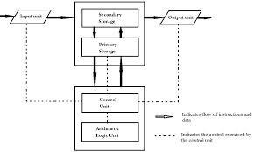

1. The interface to I/O module: The interface to I/O module is in the form of

- Control Signal – determines the function that the device will perform. E.g. send data to I/O module (READ or INPUT), receive data from I/O module (WRITE or OUTPUT), report status or perform some control function such as position a disk head. b) Data Signal – send or receive the data from I/O module. c) Status Signal – it indicates the status of signal. E.g. READY/NOT READY

  - Control Logic: associated with the device controls on specific operation as directed from I/O module.

  - Transducer: converts the data from electrical to other form of energy during output and from other forms of electrical during input.
  - Buffer: is associated with transducer to temporarily hold data during data transmission from I/O module and external environment. Buffer size of 8 to 16 bits is common.

Introduction about input-output interface:-

An I/O interface is required whenever the I/O device is driven by the processor. The interface must have necessary logic to interpret the device address generated by the processor. Handshaking should be implemented by the interface using appropriate commands (like BUSY, READY, and WAIT), and the processor can communicate with an I/O device through the interface.

It would not be practical for every I/O device to be wired to the computer in a different way, so we must have a scheme where the hardware connections are fixed, and yet the communication with the device is flexible, so that the widely varying needs of devices can all be met.

An I/O device, from the viewpoint of the CPU, is a set of registers. The CPU communicates with and controls the I/O device by reading and writing these registers. For example, SPIM, the MIPS simulator, uses two registers to communicate with the keyboard.

- The keyboard data register contains the ASCII code of the last key pressed.
- The keyboard control register indicates when a new key has been pressed. If bit 0 is one, a key has been pressed since the last character was read. The keyboard controller sets this bit when a key is pressed. It clears this bit when the keyboard data register is read.

The CPU can find out whether a new character is available by reading the keyboard control register and testing bit 0. If bit 0 is 1, it then reads the keyboard data register to get the new key.

Accessing I/O devices at the hardware level is a lot like accessing memory. The registers in the I/O devices are connected to the CPU using buses. We need an address bus to specify which I/O device register is to be accessed. We need control lines to specify what kind of access is desired (read, write, reset, etc.) Finally, we need a data bus to transfer the data between the CPU and the device.

Each device has one or more control, status, and data registers at various I/O addresses. A hypothetical example:

Address Register

ff00 keyboard status ff01 keyboard data

ff02 display status ff03 display data
ff04 disk status
ff05 disk block address ff06 disk block size ff07 disk data address
...

I/O read and write operations can be more complex than memory read and write operations, but the basic idea is the same. I/O control generally involves more than just read and write control lines. In a sense, memory can be viewed as a very simple, fast I/O device.

Whereas memory is just a large pool of slow, inexpensive registers for storing data, each I/O device register has a unique purpose in controlling a specific I/O device. This does not affect how the CPU accesses them at the hardware level, but it does affect how they are used by software.

Simple device control, such as stating whether an I/O register is to be read or written, can be done over the control lines. More complex devices are often controlled by sending special data blocks called Peripheral Control Blocks (PCBs) over the data lines. This is the primary method for communicating with disk drives, for example.

Since I/O devices are of a very different nature than CPU circuits, there must be interface hardware to connect each device to the CPU.

Example of I/O Interface

An example of an I/O interface unit is shown in figure. It consists of two data registers called ports, a control register, a status register, bus buffers and timing and control circuits.

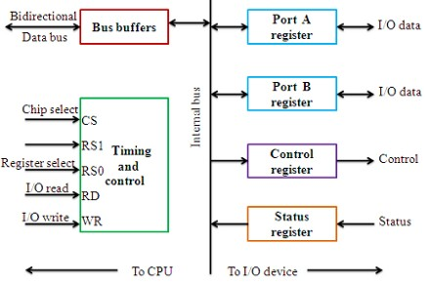

The four registers communicate directly with the I/O device attached to the interface. The I/O data to and from the device can be transferred into either port A or port B. Port A may be defined as an input port and port B may be defined as an output port. The output device such as magnetic disk transfers data in both directions. So bidirectional data bus is used. CPU gives control information to control register. The bits in the status register are used for status conditions. It is also used for recording errors that may occur during the data transfer. The bus buffers use the bidirectional data bus to communicate with the CPU. A timing and control circuit is used to detect the address assigned to the bus buffers.

CS | RS1 | RS0 | Register selected
0 | X | X | None: data bus in high- impedance
1 | 0 | 0 | Port A register
1 | 0 | 1 | Port B register
1 | 1 | 0 | Control register
1 | 1 | 1 | Status register

There are basically three type of input-output interfaces. These are as:-

- I/O bus and interface modules,.

- I/O versus memory bus.

- isolated versus memory-mapped I/O.

Introduction About Input-Output Bus And Interface Module:-

The processor of computer is communicate with several peripheral devices such as keyboard, VDU, Printer, magnetic disk, magnetic tape, etc.

Each peripheral device has its own interface . Each interface communicate with i/o bus. The communication link between processor and peripherals is shown as below:-

Each interface decode addresses and control receive from input-output bus and interpret them for peripherals and provide signal for peripheral controller . It synchronize data flow at supervise the transfer between peripherals and CPU. Each peripheral has its own controller.

For example:- Printer controller control the paper motion , the printing time and selection of printing characters.

The input-output bus fro the processor is attached to all peripheral interfaces.

The input-output bus three lines:

- Data line

- Address line.

- Control line.

1. Data line:-Data line of input-output bus carry the data to and from the peripherals.

1. Address line:-Address line contain the address of data and instructions.

1. Control line:-It contain control instructions in the form of function and input-output command. These command control instruction are of four types:-

- Control Command

- Status Command

- Data output Command

- Data input Command

- Control Command:-A control command is issue to activate the peripheral and to inform it what to do.

- Status Command:-A Status command is used to test the various status condition in the interface and the peripheral.

- Data output Command:-A Data output command is responsible for transfering the data from the bus into peripherals.

3.Data output Command:-A Data output command is responsible for transfering the data from the peripherals into input-output bus.

Introduction About Asynchronous Data Transfer:- Asynchronous Data Transfer
The internal operations in a digital system are synchronized by means of clock pulses supplied by a common pulse generator. Clock pulses are applied to all registers within a unit and all data transfers among internal registers occur simultaneously during the occurrence of a clock pulse. Two units, such as a CPU and an I/O interface, are designed independently of each other.

If the registers in the interface share a common clock with the CPU registers, the transfer between the two units is said to be synchronous. In most cases, the internal timing in each unit is independent from the other in that each uses its own private clock for internal registers.

In that case, the two units are said to be asynchronous to each other. This approach is widely used in most computer systems. Asynchronous data transfer between two independent units requires that control signals be transmitted between the communicating units to indicate the time at which data is being transmitted. One way of achieving this is by means of a strobe pulse supplied by one of the units to indicate to the other unit when the transfer has to occur.

Another method commonly used is to accompany each data item being transferred with a control signal that indicates the presence of data in the bus. The unit receiving the data item responds with another control signal to acknowledge receipt of the data. This type of agreement between two independent units is referred to as handshaking.

The strobe pulse method and the handshaking method of asynchronous data transfer are not restricted to I/O transfers. In fact, they are used extensively on numerous occasions requiring the transfer of data between two independent units. In the general case we consider the transmitting unit as the source and the receiving unit as the destination.

For example, the CPU is the source unit during an output or a write transfer and it is the destination unit during an input or a read transfer. It is customary to specify the asynchronous transfer between two independent units by means of a timing diagram that shows the timing relationship that must exist between the control signals and the data in the buses. The sequence of control during an asynchronous transfer depends on whether the transfer is initiated by the source or by the destination unit.

There are two types of asynchronous data transmittion methods:-

- Strobe control

- Handshaking.

Strobe Control

This method of asynchronous data transfer uses a single control line to time each transfer. The strobe may be activated by the source or the destination unit.

Source Initiated Data Transfer:

  - The data bus carries the information from source to destination. The strobe is a single line. The signal on this line informs the destination unit when a data word is available in the bus.
  - The strobe signal is given after a brief delay, after placing the data on the data bus. A brief period after the strobe pulse is disabled the source stops sending the data.
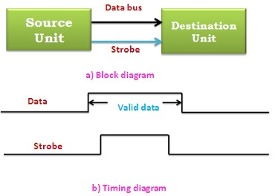

Source - initiated strobe for data transfer

- Destination Initiated Data Transfer:

  - In this case the destination unit activates the strobe pulse informing the source to send data. The source places the data on the data bus. The transmission is stopped briefly after the strobe pulse is removed.
  - The disadvantage of the strobe is that the source unit that initiates the transfer has no way of knowing whether the destination unit has received the data or not. Similarly if the destination initiates the transfer it has no way of knowing whether the source unit has placed data on the bus or not. This difficulty is solved by using hand shaking method of data transfer.

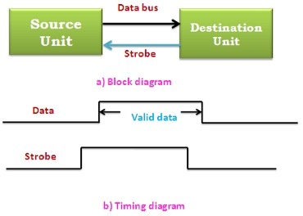

Destination - initiated strobe for data transfer

A Handshaking Protocol

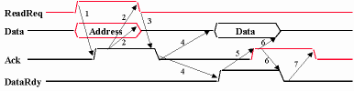

  - Three control lines
  - ReadReq: indicate a read request for memory

Address is put on the data lines at the same time

  - DataRdy: indicate the data word is now ready on the data lines

Data is put on the data lines at the same time

  - Ack: acknowledge the ReadReq or the DataRdy of the other party

Asynchronous Serial Transfer

The transfer of data between tow units my be done in parallel or serial. in parallel data transmission, total message is transmitted at the same time. In serial data transmission, each bit in the message is sent in sequence one at a time. In asynchronous transmission, binary information is sent only when it is available and the line remains idle when there is no information to be transmitted.
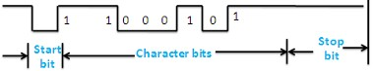

Asynchronous serial transmission

Asynchronous serial transmission is character oriented. Each character transmitter consists of a start bit, character bits, and stop bits. The first bit is called the start bit. It is always a 0 and is used to indicate the beginning of a character. The last bit called the stop bit is always a 1.

•

Introduction About Mode of transfer:-

Mode of transfer are work in between CPU and peripherals. Input peripherals sends the data to memory which is computed by CPU. The computed data is further send back to the memory and further to output peripherals.

CPU merely execute the input-output instruction and may accept the data temporary but ultimate source and destination is the memory location.

Data transfer between CPU and input-output devices may be handled in variety of modes. these are:-

Programmed input-output.

- Interrupt initiated input-output.

Direct Memory Access input-output.

Programmed I/O

  - Programmed I/O operations are the result of I/O instructions written in computer program. Each data item transfer is initiated by an instruction in the program. The I/O device does not have direct access to memory. A transfer from an I/O device

to memory requires the execution of several instructions by the CPU. The data transfer can be synchronous or asynchronous depending upon the type and the speed of the I/O devices.
  - If the speeds match then synchronous data transfer is used. When there is mismatch then asynchronous data transfer is used. The transfer is to and from a CPU register and peripheral. Other instructions are needed to transfer the data to and from CPU and memory. This method requires constant monitoring of the peripheral by the CPU. Once a data transfer is initiated the CPU is required to monitor
  - The interface to see when a transfer can again be made. In this method the CPU stays in a loop till the I/O unit indicates that it is ready for data transfer. This is time consuming process which can be solved by using interrupt.

Interrupt initiated I/O

In the programmed I/O method, the CPU stays in a program loop until the I/O unit indicates that it is ready for data transfer. This is a time-consuming process since it keeps the processor busy needlessly.

It can be avoided by using an interrupt facility and special commands to inform the interface to issue an interrupt request signal when the data are available from the device.

In the meantime the CPU can proceed to execute another program. The interface meanwhile keeps monitoring the device. When the interface determines that the device is ready for data
transfer, it generates an interrupt request to the computer.

Upon detecting the external interrupt signal, the CPU momentarily stops the task it is processing, branches to a service program to process the I/O transfer, and then returns to the task it was originally performing.

Example of Interrupt initiated I/O:

- Vectored interrupt
- Non vectored interrupt

Vectored interrupt :
In vectored interrupt, the source that interrupts supplies the branch information to the computer. This information is called the interrupt vector.

Non vectored interrupt
In a non vectored interrupt, the branch address is assigned to a fixed location in memory.

Direct Memory Access

DMA Short for direct memory access, a technique for transferring data from main memory to a device without passing it through the CPU. Computers that have DMA channels can transfer data to and from devices much more quickly than computers without a DMA channel can. This is useful for making quick backups and for real-time applications. Some expansion boards, such as CD-ROM cards, are capable of accessing the computer's DMA channel. When you install the board, you must specify which DMA channel is to be used, which sometimes involves setting a jumper or DIP switch.
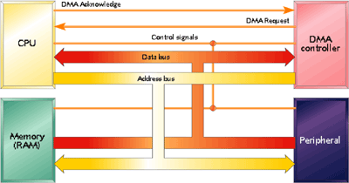

Direct Memory Access interactions Direct Memory Access Controller
DMA controller is used to transfer the data between the memory and i/o device.

  - The DMA controller needs the usual circuits to communicate with the CPU and i/o device.
  - In addition to this, it needs an address register and address bus buffer.
  - The address register contains an address of the desired location in memory.
  - The word count register holds the number of words to be transferred. The control register specifies the mode of transfer.
  - The DMA communicates with the i/o devices through the DMA request and DMA acknowledge line.
  - The DMA communicates with the CPU through the data bus and control lines.
  - The RD (Read) and WR (write) signals are bidirectional.
  - When the BG (Bus Grant) signal are bidirectional.
  - When the BG (Bus Grant) signal is 0, the CPU can communicate with the DMA registers through the data bus.
  - When BG is 1, the CPU has relinquished the buses. The the DMA can communicate directly with the memory.

DMA Transfer

The connection between the DMA controller and other components in a computer system for DMA transfer is shown in figure.
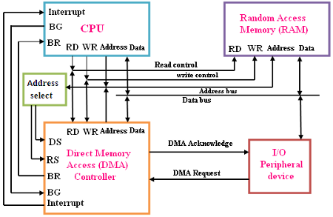

DMA transfer in a computer system

  - The DMA request line is used to request a DMA transfer.
  - The bus request (BR) signal is used by the DMA controller to request the CPU to relinquish control of the buses.
  - The CPU activates the bus grant (BG) output to inform the external DMA that its buses are in a high-impedance state (so that they can be used in the DMA transfer.)
  - The address bus is used to address the DMA controller and memory at given location
  - The Device select (DS) and register select (RS) lines are activated by addressing the DMA controller.
  - The RD and WR lines are used to specify either a read (RD) or write (WR) operation on the given memory location.
  - The DMA acknowledge line is set when the system is ready to initiate data transfer.
  - The data bus is used to transfer data between the I/O device and memory.
  - When the last word of data in the DMA transfer is transferred, the DMA controller informs the termination of the transfer to the CPU by means of the interrupt line.

I/O Programming

The IOP is similar to a CPU except that it is designed to handle the details of I/O processing. The IOP can fetch and execute its own instructions. IOP instructions are specifically designed to facilitate I/O transfers.

  - The memory unit occupies a central position and can communicate with each processor by means of direct memory access. The CPU is responsible for processing data needed in the solution of computation tasks. The IOP provides a path for transfer of data between various peripheral devices and the memory unit.
  - The CPU performs the task of initiating the I/O program. Then the IOP operates independent of the CPU and continues to transfer data. The data is transferred between the external devices and memory.
  - The data formats of peripheral devices differ from memory and CPU data formats. The IOP must structure data words from many different sources. For example, it may be necessary to take four bytes from an input device and pack them into one 32-bit word before the transfer to memory.
  - Data are gathered in the IOP at the device rate and bit capacity while the CPU is executing its own program. After the input data are assembled into a memory word, they are transferred from IOP directly into memory by "stealing" one memory cycle from the CPU.
  - Similarly, an output word transferred from memory to the IOP is directed from the IOP to the output device at the device rate and bit capacity. The IOP responds to CPU request by placing its status word in memory location which is further examined by the CPU. Instructions that are nread from memory to IOP are called commands

CPU - IOP Communications

The communication between CPU and IOP may take different forms depending on the particular computer considered.

The CPU sends a test I/O instruction to IOP to test the IOP path.

  - The responds by inserting a status word in memory location.
  - The CPU refers to the status word in memory. If everything is in order, the CPU sends the start I/O instruction to start the I/O transfer.
  - The IOP accesses memory for IOP program.
  - The CPU can now continue with another program while the IOP is busy with the program. Both programs refer to memory by means of DMA transfer.
  - When the IOP terminates the execution of its program, it sends an interrupt request to the CPU.
  - The CPU then issues a read I/O instruction to read the status from the IOP.
  - The IOP transfers the status word to memory location.
  - The status word indicates whether the transfer has been completed satisfactorily or if any error has occurred during the transfer.

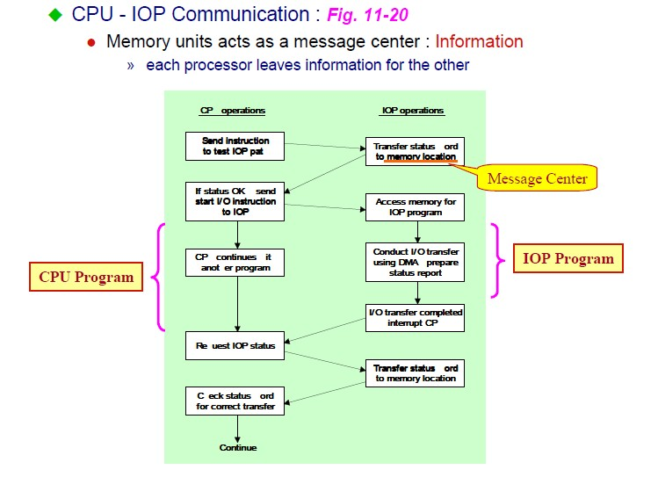

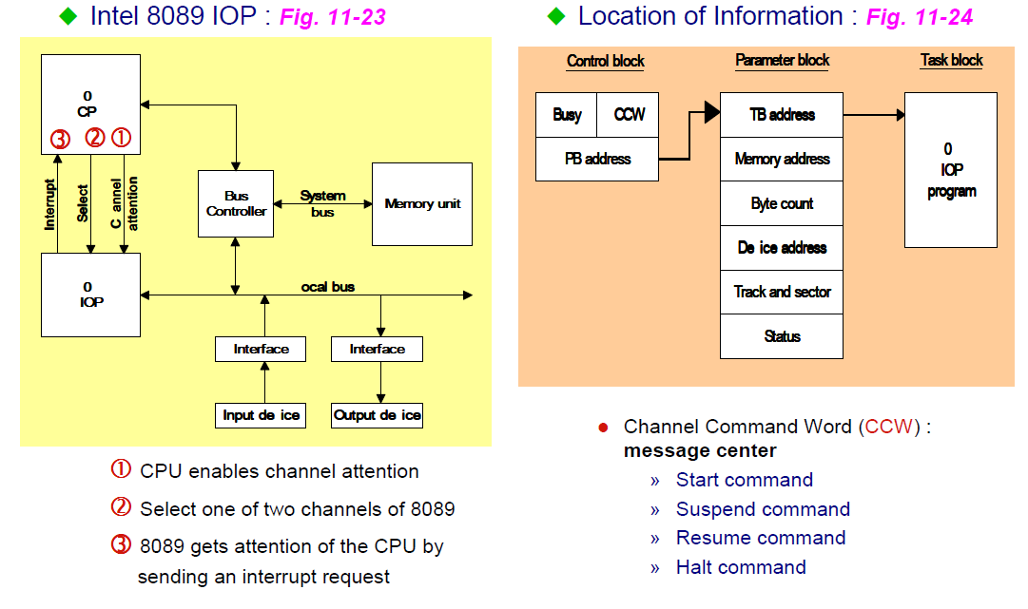

Unit III

Memory Hierarchy
- The memory unit is an essential component in any digital computer since it is needed for storing programs and data
- Not all accumulated information is needed by the CPU at the same time

- Therefore, it is more economical to use low-cost storage devices to serve as a backup for storing the information that is not currently used by CPU
- The memory unit that directly communicate with CPU is called the main memory

- Devices that provide backup storage are called auxiliary memory

- The memory hierarchy system consists of all storage devices employed in a computer system from the slow by high-capacity auxiliary memory to a relatively faster main memory, to an even smaller and faster cache memory
- The main memory occupies a central position by being able to communicate directly with the CPU and with auxiliary memory devices through an I/O processor
- A special very-high-speed memory called cache is used to increase the speed of processing by making current programs and data available to the CPU at a rapid rate
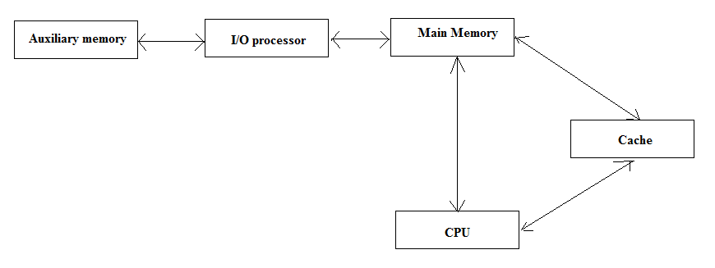
CPU logic is usually faster than main memory access time, with the result that processing speed is limited primarily by the speed of main memory
- The cache is used for storing segments of programs currently being executed in the CPU and temporary data frequently needed in the present calculations
- The typical access time ratio between cache and main memory is about 1to7 Auxiliary memory access time is usually 1000 times that of main memory

Main Memory
- Most of the main memory in a general purpose computer is made up of RAM integrated circuits chips, but a portion of the memory may be constructed with ROM chips
- RAM– Random Access memory

  - In tegated RAM are available in two possible operating modes, Static and Dynamic
- ROM– Read Only memory

Random-Access Memory (RAM) Static RAM (SRAM)
  - Each cell stores bit with a six-transistor circuit.

  - Retains value indefinitely, as long as it is kept powered.

  - Relatively insensitive to disturbances such as electrical noise.
  - Faster and more expensive than DRAM. Dynamic RAM (DRAM)
  - Each cell stores bit with a capacitor and transistor.

  - Value must be refreshed every 10-100 ms.

  - Sensitive to disturbances.

  - Slower and cheaper than SRAM.

ROM
- ROM is used for storing programs that are PERMENTLY resident in the computer and for tables of constants that do not change in value once the production of the computer is completed
- The ROM portion of main memory is needed for storing an initial program called bootstrap loader, witch is to start the computer software operating when power is turned off
A RAM chip is better suited for communication with the CPU if it has one or more control inputs that select the chip when needed
The Block diagram of a RAM chip is shown next slide, the capacity of the memory is 128 words of 8 bits (one byte) per word

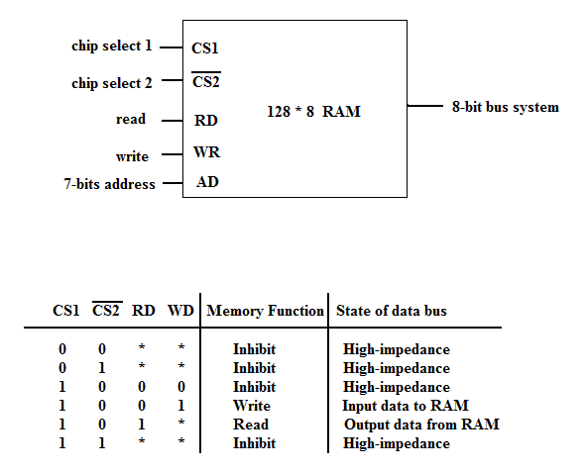

ROM
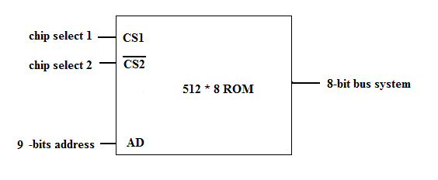

Memory Address Map

- Memory Address Map is a pictorial representation of assigned address space for each chip in the system
- To demonstrate an example, assume that a computer system needs 512 bytes of RAM and 512 bytes of ROM
- The RAM have 128 byte and need seven address lines, where the ROM have 512 bytes and need 9 address lines
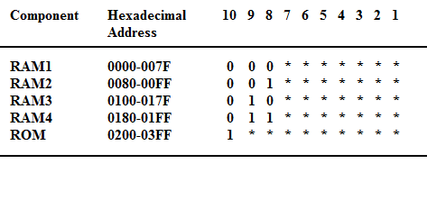
- The hexadecimal address assigns a range of hexadecimal equivalent address for each chip
- Line 8 and 9 represent four distinct binary combination to specify which RAM we chose
- When line 10 is 0, CPU selects a RAM. And when it’s 1, it selects the ROM

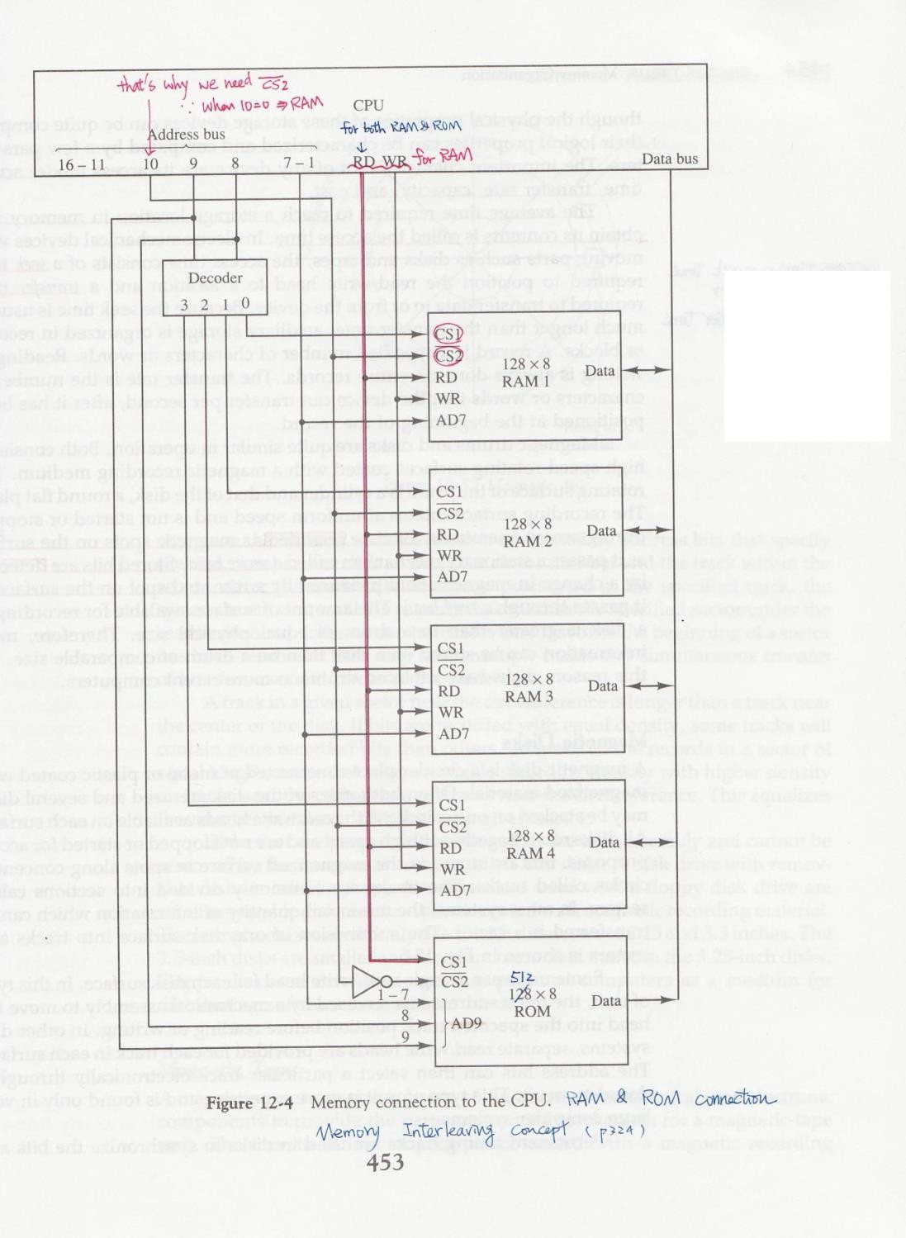
Cache memory
- If the active portions of the program and data are placed in a fast small memory, the average memory access time can be reduced,
- Thus reducing the total execution time of the program

- Such a fast small memory is referred to as cache memory

- The cache is the fastest component in the memory hierarchy and approaches the speed of CPU component
- When CPU needs to access memory, the cache is examined

- If the word is found in the cache, it is read from the fast memory

- If the word addressed by the CPU is not found in the cache, the main memory is accessed to read the word
- The performance of cache memory is frequently measured in terms of a quantity called hit ratio
- When the CPU refers to memory and finds the word in cache, it is said to produce a hit
- Otherwise, it is a miss

Hit ratio = hit / (hit+miss)

- The basic characteristic of cache memory is its fast access time,

- Therefore, very little or no time must be wasted when searching the words in the cache
- The transformation of data from main memory to cache memory is referred to as a
mapping process, there are three types of mapping:

  - Associative mapping

  - Direct mapping

  - Set-associative mapping

To help understand the mapping procedure, we have the following example:

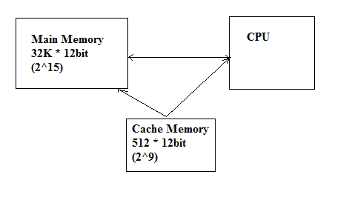
Associative mapping
- The fastest and most flexible cache organization uses an associative memory

- The associative memory stores both the address and data of the memory word

- This permits any location in cache to store ant word from main memory

- The address value of 15 bits is shown as a five-digit octal number and its corresponding 12-bit word is shown as a four-digit octal number

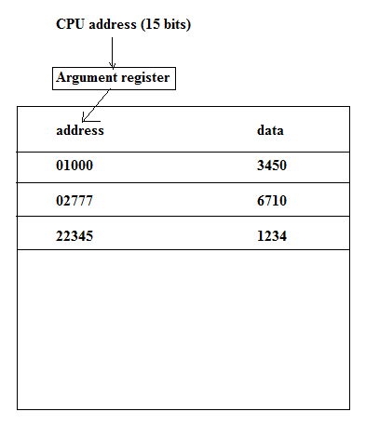
- A CPU address of 15 bits is places in the argument register and the associative memory us searched for a matching address
- If the address is found, the corresponding 12-bits data is read and sent to the CPU

- If not, the main memory is accessed for the word

- If the cache is full, an address-data pair must be displaced to make room for a pair that is needed and not presently in the cache
Direct Mapping
- Associative memory is expensive compared to RAM

- In general case, there are 2^k words in cache memory and 2^n words in main memory (in our case, k=9, n=15)
- The n bit memory address is divided into two fields: k-bits for the index and n-k bits for the tag field

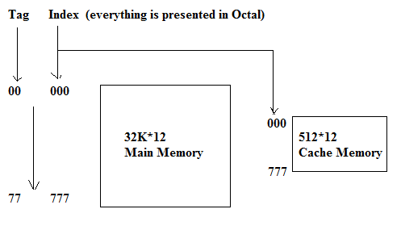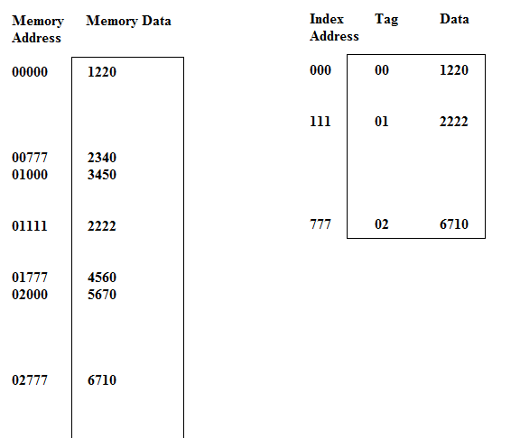

Set-Associative Mapping
- The disadvantage of direct mapping is that two words with the same index in their address but with different tag values cannot reside in cache memory at the same time
- Set-Associative Mapping is an improvement over the direct-mapping in that each word of cache can store two or more word of memory under the same index address

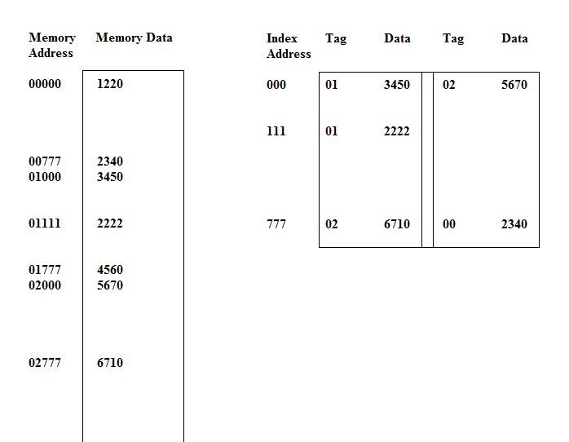
■
In the slide, each index address refers to two data words and their associated tags

- Each tag requires six bits and each data word has 12 bits, so the word length is 2*(6+12) = 36 bits
Virtual Memory
- The address used by a programmer will be called a virtual address or logical address.
- An address in main memory is called a physical address

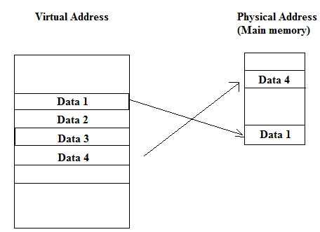
- The term page refers to groups of address space of the same size

- For example: if auxiliary memory contains 1024K and main memory contains 32K and page size equals to 1K, then auxiliary memory has 1024 pages and main memory has 32 pages
- Only part of the program needs to be in memory for execution

- Logical address space can therefore be much larger than physical address space

- Allows for more efficient process creation
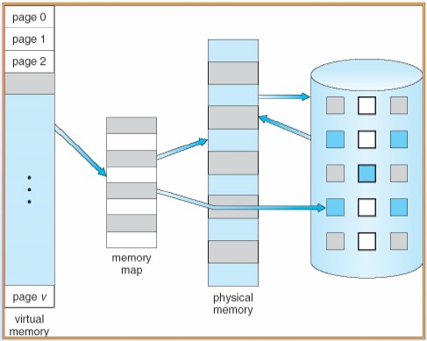

Demand Paging
- In stead of loading whole program into memory, demand paging is an alternative strategy to initially load pages only as they are needed
- Lazy Swapper: Pages are only loaded when they are demanded during program execution
Transfer of a page memory to continuous disk space
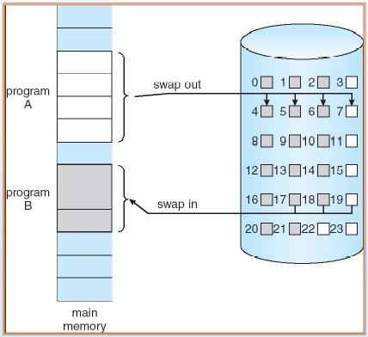
- When a process is to be swapped in, the pager guesses which pages will be used before the process is swapped out again.
- Instead of swapping in a whole process, the pager brings only those necessary pages into memory

Valid-Invalid Bit
- With each page table entry a

valid–invalid bit is associated
(v=> in-memory , i =>not-in-memory)
- Initially valid–invalid bit is set to i on all entries

- During address translation, if valid–invalid bit in page table entry is i => page fault

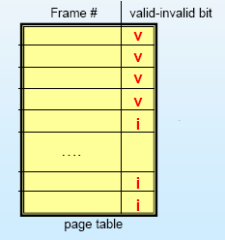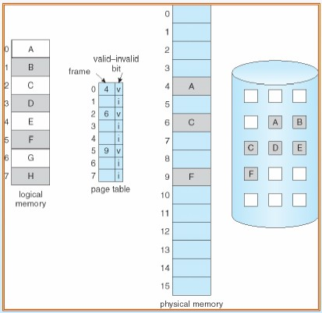
Page Fault

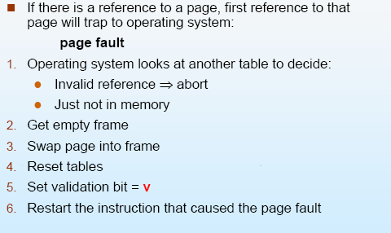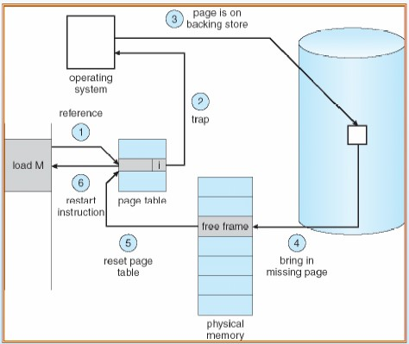
Performance of Demand Paging

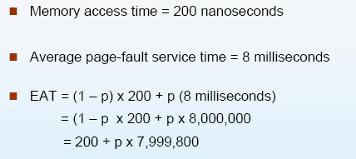
■
If we want performance degradation to be less than 10%, we need

220 > 200+7,999,800*p
20>7,999,800*p P<0.0000025
It is important to keep the page-fault rate low in a demand-paging system
Page Replacement
- What if there is no free frame?

- Page replacement –find some page in memory, but not really in use, swap it out

- In this case, same page may be brought into memory several times
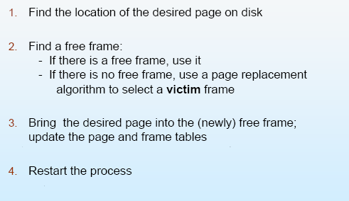

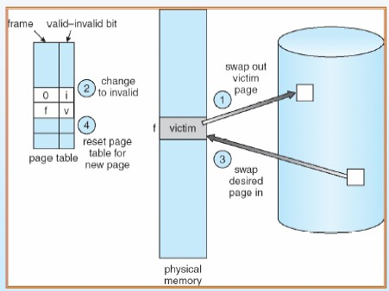

Unit IV

8086 Architecture

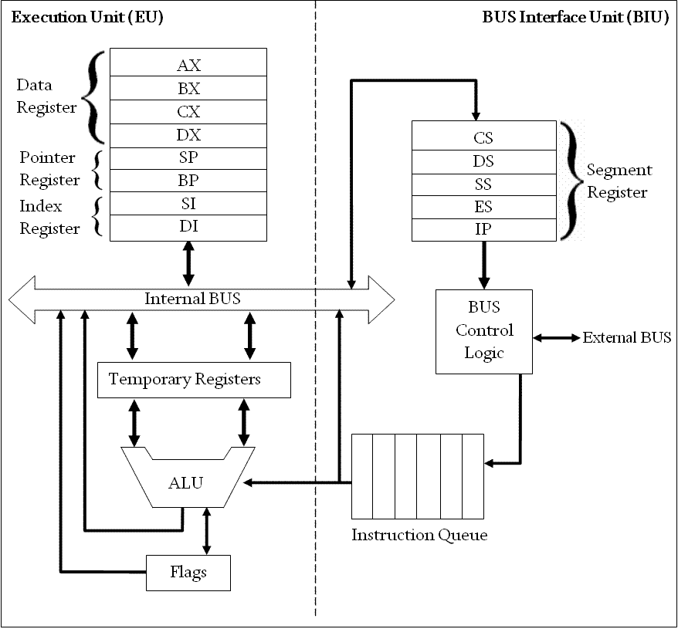

8086 microprocessor has two units; Execution Unit (EU) and Bus Interface Unit (BIU). They are dependent and get worked by each other. Below is a short description of these two units.

Execution Unit (EU):

Execution unit receives program instruction codes and data from the BIU, executes them and stores the results in the general registers. It can also store the data in a memory location or send them to an I/O device by passing the data back to the BIU. This unit, EU, has no connection with the system Buses. It receives and outputs all its data through BIU.

ALU (Arithmetic and Logic Unit) : The EU unit contains a circuit board called the Arithmetic and Logic Unit. The ALU can perform arithmetic, such as, +,-,×,/ and logic such as OR, AND, NOT operations.
Registers : A register is like a memory location where the exception is that these are denoted by name rather than numbers. It has 4 data registers, AX, BX, CX, DX and 2 pointer registers SP, BP and 2 index registers SI, DI and 1 temporary register and 1 status register FLAGS .
AX, BX, CX and DX registers has 2 8-bit registers to access the high and low byte data registers. The high byte of AX is called AH and the low byte is AL. Similarly, the high and low bytes of BX, CX, DX are BH and BL, CH and Cl, DH and DL respectively. All the data, pointer, index and status registers are of 16 bits. Else these, the temporary register holds the operands for the ALU and the individual bits of the FLAGS register reflect the result of a computation.

Bus Interface Unit:

As the EU has no connection with the system Busses, this job is done by BIU. BIU and EU are connected with an internal bus. BIU connects EU with the memory or I/O circuits. It is responsible for transmitting data, addresses and control signal on the busses. Registers : BIU has 4 segment busses, CS, DS, SS, ES. These all 4 segment registers holds the addresses of instructions and data in memory. These values are used by the processor to access memory locations. It also contain 1 pointer register IP. IP contains the address of the next instruction to executed by the EU.
Instruction Queue : BIU also contain an instruction queue. When the EU executes instructions, the BIU gets up to 6 bytes of the next instruction and stores them in the instruction queue and this process is called instruction prefetch. This is a process to speed up the processor. Also when the EU needs to be connected with memory or peripherals, BIU suspends instruction prefetch and performs the needed operations.

ALU (Arithmetic & Logic Unit)

This unit can perform various arithmetic and logical operation, if required, based on the instruction to be executed. It can perform arithmetical operations, such as add, subtract, increment, decrement, convert byte/word and compare etc and logical operations, such as AND, OR, exclusive OR, shift/rotate and test etc.

Purpose of using Instruction Queue:

BIU contains an instruction queue. When the EU executes instructions, the BIU gets up to 6 bytes of the next instruction and stores them in the instruction queue and this process is called instruction prefetch. This is a process to speed up the processor. A subtle advantage of instruction queue is that, as next several instructions are usually in the queue, the BIU can access memory at a somewhat "leisurely" pace. This means that slow- memory parts can be used without affecting overall system performance.

Registers

Data Registers

  - AX = Accumulator Register
  - BX = Base Register
  - DX = Data Register
  - CX = Count Register

Index Registers

  - SI = Source Index
  - DI = Destination Index

Segment Registers

  - DS = Data Segment
  - SS = Stack Segment
  - ES = Extra Segment
  - CS = Code Segment

Pointer Registers

  - IP = Instruction Pointer
  - BP = Base Pointer
  - SP = Stack Pointer

Segment Register:

CS (Code Segment) :

Code segment (CS) is a 16-bit register containing address of 64 KB segment with processor instructions. The processor uses CS segment for all accesses to instructions referenced by instruction pointer (IP) register. CS register cannot be changed directly. The CS register is automatically updated during far jump, far call and far return instructions.

Stack segment (SS)

is a 16-bit register containing address of 64KB segment with program stack. By default, the processor assumes that all data referenced by the stack pointer (SP) and base pointer (BP) registers is located in the stack segment. SS register can be changed directly using POP instruction.

Data segment (DS)

is a 16-bit register containing address of 64KB segment with program data. By default, the processor assumes that all data referenced by general registers (AX, BX, CX, DX) and index register (SI, DI) is located in the data segment. DS register can be changed directly using POP and LDS instructions.

Extra segment (ES)

is a 16-bit register containing address of 64KB segment, usually with program data. By default, the processor assumes that the DI register references the ES segment in string manipulation instructions. ES register can be changed directly using POP and LES instructions. It is possible to change default segments used by general and index registers by prefixing instructions with a CS, SS, DS or ES prefix.

IP (Instruction Pointer) :

To access instructions the 8086 uses the registers CS and IP. The CS register contains the segment number of the next instruction and the IP contains the offset. IP is updated each time an instruction is executed so that it will point to the next instruction. Unlike other registers the IP can’t be directly manipulated by an instruction, that is, an instruction may not contain IP as its operand.

General Registers :

All general registers of the 8086 microprocessor can be used for arithmetic and logic operations. The general registers are:

AX (Accumulator):

This is accumulator register. It gets used in arithmetic, logic and data transfer instructions. In manipulation and division , one of the numbers involved must be in AX or AL.

BX (Base Register):

This is base register. BX register is an address register. It usually contain a data pointer used for based, based indexed or register indirect addressing.

CX (Count register):

This is Count register. This serves as a loop counter. Program loop constructions are facilitated by it. Count register can also be used as a counter in string manipulation and shift/rotate instruction.

DX (Data Register):

This is data register. Data register can be used as a port number in I/O operations. It is also used in multiplication and division.

SP (Stack Pointer):

This is stack pointer register pointing to program stack. It is used in conjunction with SS for accessing the stack segment.

BP (Base Pointer):

This is base pointer register pointing to data in stack segment. Unlike SP, we can use BP to access data in the other segments.

SI (Source Index):

This is source index register which is used to point to memory locations in the data segment addressed by DS. By incrementing the contents of SI one can easily access consecutive memory locations.

DI (Destination Index):

This is destination index register performs the same function as SI. There is a class of instructions called string operations, that use DI to access the memory locations addressed by ES.

Pin Diagram and Pin description of 8086

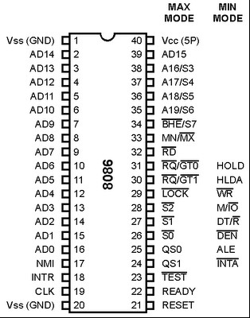

The following pin function descriptions are for the microprocessor 8086 in either minimum or maximum mode.

AD0 - AD15 (I/O): Address Data Bus

These lines constitute the time multiplexed memory/IO address during the first clock cycle (T1) and data during T2, T3 and T4 clock cycles. A0 is analogous to BHE for the lower byte of the data bus, pins D0-D7. A0 bit is Low during T1 state when a byte is to be transferred on the lower portion of the bus in memory or I/O operations. 8-bit oriented devices tied to the lower half would normally use A0 to condition chip select functions. These lines are active high and float to tri-state during interrupt acknowledge and local bus "Hold acknowledge".

A19/S6, A18/S5, A17/S4, A16/S3 (0): Address/Status

During T1 state these lines are the four most significant address lines for memory operations. During I/O operations these lines are low. During memory and I/O operations, status information is available on these lines during T2, T3, and T4 states.S5: The status of the interrupt enable flag bit is updated at the beginning of each cycle. The status of the flag is indicated through this bus.

S6:

When Low, it indicates that 8086 is in control of the bus. During a "Hold acknowledge" clock period, the 8086 tri-states the S6 pin and thus allows another bus master to take control of the status bus.

S3 & S4:

Lines are | decode | d as follows:
A17/S4 | A16/S3 | Function
0 | 0 | Extra segment access
0 | 1 | Stack segment access
1 | 0 | Code segment access
1 | 1 | Data segment access

After the first clock cycle of an instruction execution, the A17/S4 and A16/S3 pins specify which segment register generates the segment portion of the 8086 address. Thus by decoding these lines and using the decoder outputs as chip selects for memory chips, up to 4 Megabytes (one Mega per segment) of memory can be accesses. This feature also provides a degree of protection by preventing write operations to one segment from

erroneously overlapping into another segment and destroying information in that segment.

BHE /S7 (O): Bus High Enable/Status

During T1 state theBHE should be used to enable data onto the most significant half of the data bus, pins D15 - D8. Eight-bit oriented devices tied to the upper half of the bus would normally use BHE to control chip select functions. BHE is Low during T1 state of read, write and interrupt acknowledge cycles when a byte is to be transferred on the high portion of the bus.
The S7 status information is available during T2, T3 and T4 states. The signal is active Low and floats to 3-state during "hold" state. This pin is Low during T1 state for the first interrupt acknowledge cycle.

RD (O): READ

The Read strobe indicates that the processor is performing a memory or I/O read cycle. This signal is active low during T2 and T3 states and the Tw states of any read cycle. This signal floats to tri-state in "hold acknowledge cycle".

TEST (I)

TEST pin is examined by the "WAIT" instruction. If the TEST pin is Low, execution continues. Otherwise the processor waits in an "idle" state. This input is synchronized internally during each clock cycle on the leading edge of CLK.

INTR (I): Interrupt Request

It is a level triggered input which is sampled during the last clock cycle of each instruction to determine if the processor should enter into an interrupt acknowledge operation. A subroutine is vectored to via an interrupt vector look up table located in system memory. It can be internally masked by software resetting the interrupt enable bit INTR is internally synchronized. This signal is active HIGH.

NMI (I): Non-Muskable Interrupt

An edge triggered input, causes a type-2 interrupt. A subroutine is vectored to via the interrupt vector look up table located in system memory. NMI is not maskable internally by software. A transition from a LOW to HIGH on this pin initiates the interrupt at the end of the current instruction. This input is internally synchronized.

Reset (I)

Reset causes the processor to immediately terminate its present activity. To be recognised, the signal must be active high for at least four clock cycles, except after power-on which requires a 50 Micro Sec. pulse. It causes the 8086 to initialize registers DS, SS, ES, IP and flags to all zeros. It also initializes CS to FFFF H. Upon removal of the RESET signal from the RESET pin, the 8086 will fetch its next instruction from the 20 bit physical address FFFF0H. The reset signal to 8086 can be generated by the 8284. (Clock generation chip). To guarantee reset from power-up, the reset input must remain below 1.5 volts for 50 Micro sec. after Vcc has reached the minimum supply voltage of 4.5V.

Ready (I)

Ready is the acknowledgement from the addressed memory or I/O device that it will complete the data transfer. The READY signal from memory or I/O is synchronized by the 8284 clock generator to form READY. This signal is active HIGH. The 8086 READY input is not synchronized. Correct operation is not guaranteed if the setup and hold times are not met.

CLK (I): Clock

Clock provides the basic timing for the processor and bus controller. It is asymmetric with 33% duty cycle to provide optimized internal timing. Minimum frequency of 2 MHz is required, since the design of 8086 processors incorporates dynamic cells. The maximum clock frequencies of the 8086-4, 8086 and 8086-2 are4MHz, 5MHz and 8MHz respectively.
Since the 8086 does not have on-chip clock generation circuitry, and 8284 clock generator chip must be connected to the 8086 clock pin. The crystal connected to 8284 must have a frequency 3 times the 8086 internal frequency. The 8284 clock generation chip is used to generate READY, RESET and CLK.

MN/MX (I): Maximum / Minimum

This pin indicates what mode the processor is to operate in. In minimum mode, the 8086 itself generates all bus control signals. In maximum mode the three status signals are to be decoded to generate all the bus control signals.
Minimum Mode Pins The following 8 pins function descriptions are for the 8086 in

minimum mode; MN/ MX = 1. The corresponding 8 pins function descriptions for maximum mode is explained later.

M/IO (O): Status line

This pin is used to distinguish a memory access or an I/O accesses. When this pin is Low, it accesses I/O and when high it access memory. M / IO becomes valid in the T4 state preceding a bus cycle and remains valid until the final T4 of the cycle. M/IO floats to 3 - state OFF during local bus "hold acknowledge".

WR (O): Write

Indicates that the processor is performing a write memory or write IO cycle, depending on the state of the M /IOsignal. WR is active for T2, T3 and Tw of any write cycle. It is active LOW, and floats to 3-state OFF during local bus "hold acknowledge ".

INTA (O): Interrupt Acknowledge

It is used as a read strobe for interrupt acknowledge cycles. It is active LOW during T2, T3, and T4 of each interrupt acknowledge cycle.

ALE (O): Address Latch Enable

ALE is provided by the processor to latch the address into the 8282/8283 address latch. It is an active high pulse during T1 of any bus cycle. ALE signal is never floated.

DT/ R (O): DATA Transmit/Receive

In minimum mode, 8286/8287 transceiver is used for the data bus. DT/ R is used to control the direction of data flow through the transceiver. This signal floats to tri-state off during local bus "hold acknowledge".

DEN (O): Data Enable

It is provided as an output enable for the 8286/8287 in a minimum system which uses the transceiver. DEN is active LOW during each memory and IO access. It will be low beginning with T2 until the middle of T4, while for a write cycle, it is active from the beginning of T2 until the middle of T4. It floats to tri-state off during local bus "hold acknowledge".

HOLD & HLDA (I/O): Hold and Hold Acknowledge

Hold indicates that another master is requesting a local bus "HOLD". To be acknowledged, HOLD must be active HIGH. The processor receiving the "HOLD " request will issue HLDA (HIGH) as an acknowledgement in the middle of the T1-clock cycle. Simultaneous with the issue of HLDA, the processor will float the local bus and control lines. After "HOLD" is detected as being Low, the processor will lower the HLDA and when the processor needs to run another cycle, it will again drive the local bus and control lines.
Maximum Mode The following pins function descriptions are for the 8086/8088 systems in maximum mode (i.e.. MN/MX = 0). Only the pins which are unique to maximum mode are described below.

S2, S1, S0 (O): Status Pins

These pins are active during T4, T1 and T2 states and is returned to passive state (1,1,1 during T3 or Tw (when ready is inactive). These are used by the 8288 bus controller to generate all memory and I/O operation) access control signals. Any change by S2, S1, S0 during T4 is used to indicate the beginning of a bus cycle. These status lines are encoded as shown in table 3.

S2 | S1 | S0 | Characteristics
0 | 0 | 0 | Interrupt acknowledge
0 | 0 | 1 | Read I/O port
0 | 1 | 0 | Write I/O port
0 | 1 | 1 | Halt
1 | 0 | 0 | Code access1 0 1 Read memory
1 | 1 | 0 | Write memory
1 | 1 | 1 | Passive State
Table 3

QS0, QS1 (O): Queue – Status

Queue Status is valid during the clock cycle after which the queue operation is performed. QS0, QS1 provide status to allow external tracking of the internal 8086 instruction queue. The condition of queue status is shown in table 4.

Queue status allows external devices like In-circuit Emulators or special instruction set extension co-processors to track the CPU instruction execution. Since instructions are executed from the 8086 internal queue, the queue status is presented each CPU clock cycle and is not related to the bus cycle activity. This mechanism allows (1) A processor to detect execution of a ESCAPE instruction which directs the co- processor to perform a specific task and (2) An in-circuit Emulator to trap execution of a specific memory location.
QS1 | QS1 | Characteristics

0 | 0 | No operation
0 | 1 | First byte of opcode from queue
1 | 0 | Empty the queue
1 | 1 | Subsequent byte from queue
Table 4

LOCK (O)

It indicates to another system bus master, not to gain control of the system bus while LOCK is active Low. The LOCK signal is activated by the "LOCK" prefix instruction and remains active until the completion of the instruction. This signal is active Low and floats to tri-state OFF during 'hold acknowledge'. Example:
LOCK XCHG reg., Memory ; Register is any register and memory GT0
; is the address of the semaphore.

RQ/GT0 and RQ/GT1 (I/O): Request/Grant

These pins are used by other processors in a multi processor organization. Local bus masters of other processors force the processor to release the local bus at the end of the processors current bus cycle. Each pin is bi-directional and has an internal pull up resistors. Hence they may be left un-connected.

Flag Registers

The 8086 microprocessor has a 16 bit register for flag register. In this register 9 bits are active for flags. This register has 9 flags which are divided into two parts that are as follows

Conditional Flags

Conditional flags represent result of last arithmetic or logical instruction executed. Conditional flags are as follows:

CF (Carry Flag)

This flag indicates an overflow condition for unsigned integer arithmetic. It is also used in multiple-precision arithmetic.

AF (Auxiliary Flag)

If an operation performed in ALU generates a carry/barrow from lower nibble (i.e. D0 – D3) to upper nibble (i.e. D4 – D7), the AF flag is set i.e. carry given by D3 bit to D4 is AF flag. This is not a general-purpose flag; it is used internally by the processor to perform Binary to BCD conversion.

PF (Parity Flag)

This flag is used to indicate the parity of result. If lower order 8-bits of the result contains even number of 1’s, the Parity Flag is set and for odd number of 1’s, the Parity Flag is reset.

ZF (Zero Flag)

It is set; if the result of arithmetic or logical operation is zero else it is reset.

SF (Sign Flag)

In sign magnitude format the sign of number is indicated by MSB bit. If the result of operation is negative, sign flag is set.

OF (Overflow Flag)

This stands for over flow flag. It occurs when signed numbers are added or subtracted. An OF indicates that the result has exceeded the capacity of machine. It becomes set if the sign result cannot express within the number of bites.

Control Flags

Control flags are set or reset deliberately to control the operations of the execution unit. Control flags are as follows:

TF (Trap Flag):

It is used for single step control. It allows user to execute one instruction of a program at a time for debugging. When trap flag is set, program can be run in single step mode.

IF (Interrupt Flag):

It is an interrupt enable/disable flag. This stands for interrupt flag. This flag is used to enable or disable the interrupt in a program. If it is set, the maskable interrupt of 8086 is enabled and if it is reset, the interrupt is disabled. It can be set by executing instruction sit and can be cleared by executing CLI instruction.

DF (Direction Flag):

This flag stands for direction flag and is used for the direction of strings. If it is set, string bytes are accessed from higher memory address to lower memory address. When it is reset, the string bytes are accessed from lower memory address to higher memory address

Unit-V

Instruction Set of 8086
The 8086 instructions are categorized into the following main types.
  - Data Copy / Transfer Instructions
  - Arithmetic and Logical Instructions
  - Branch Instructions
  - Loop Instructions
  - Machine Control Instructions
  - Flag Manipulation Instructions
  - Shift and Rotate Instructions
  - String Instructions

Data Copy / Transfer Instructions :

MOV :
This instruction copies a word or a byte of data from some source to a destination. The destination can be a register or a memory location. The source can be a register, a memory location, or an immediate number.
MOV AX,BX MOV AX,5000H MOV AX,[SI] MOV AX,[2000H] MOV AX,50H[BX] MOV [734AH],BX MOV DS,CX MOV CL,[357AH]
Direct loading of the segment registers with immediate data is not permitted.

2

PUSH : Push to Stack
This instruction pushes the contents of the specified register/memory location on to the stack. The stack pointer is decremented by 2, after each execution of the instruction.
E.g. PUSH AX
  - PUSH DS
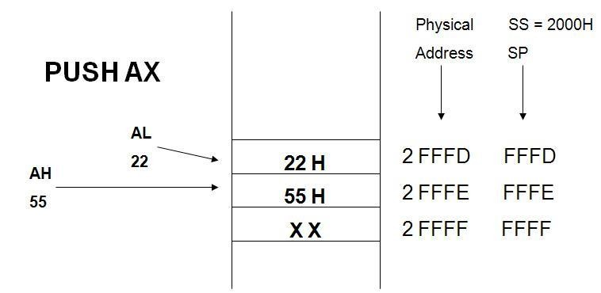
  - PUSH [5000H]

Fig. 2.2 Push Data to stack memory

POP : Pop from Sack
This instruction when executed, loads the specified register/memory location with the contents of the memory location of which the address is formed using the current stack segment and stack pointer.
The stack pointer is incremented by 2 Eg. POP AX
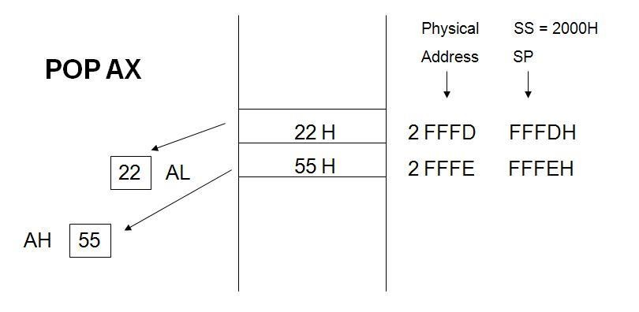
POP DS POP [5000H]

Fig 2.3 Popping Register Content from Stack Memory XCHG : Exchange byte or word
This instruction exchange the contents of the specified source and destination
operands
Eg. XCHG | [5000H], AX
XCHG | BX, AX

XLAT :
Translate byte using look-up table Eg. LEA BX, TABLE1
MOV AL, 04H XLAT
Simple input and output port transfer Instructions:

IN:
Copy a byte or word from specified port to accumulator. Eg. IN AL,03H
IN AX,DX

OUT:
Copy a byte or word from accumulator specified port. Eg. OUT 03H, AL
OUT DX, AX

LEA :
Load effective address of operand in specified register. [reg] offset portion of address in DS
Eg. LEA reg, offset

LDS:
Load DS register and other specified register from memory. [reg] [mem]
[DS] [mem + 2]
Eg. LDS reg, mem

LES:
Load ES register and other specified register from memory. [reg] [mem]
[ES] [mem + 2]
Eg. LES reg, mem

Flag transfer instructions:
LAHF:
Load (copy to) AH with the low byte the flag register. [AH] [ Flags low byte]
Eg. LAHF

SAHF:
Store (copy) AH register to low byte of flag register. [Flags low byte] [AH]
Eg. SAHF

PUSHF:
Copy flag register to top of stack.
[SP] | [SP] – 2
[[SP]] | [Flags]
Eg. PUSHF

POPF :
Copy word at top of stack to flag register.
[Flags] | [[SP]]
[SP] | [SP] + 2

Arithmetic Instructions:
The 8086 provides many arithmetic operations: addition, subtraction, negation, multiplication and comparing two values.

ADD :

ADD AX, 0100H ADD AX, BX ADD AX, [SI] ADD AX, [5000H]
ADD [5000H], 0100H ADD 0100H

The add instruction adds the contents of the source operand to the destination
operand. Eg.

ADC : Add with Carry
This instruction performs the same operation as ADD instruction, but adds the carry

flag to the result.
Eg. ADC
ADC ADC

ADC ADC
0100H AX, BX AX, [SI] AX, [5000]
[5000], 0100H

SUB : Subtract
The subtract instruction subtracts the source operand from the destination operand and the result is left in the destination operand.
Eg. SUB AX, 0100H
SUB AX, BX SUB AX, [5000H]
SUB [5000H], 0100H

SBB : Subtract with Borrow

SBB AX, 0100H SBB AX, BX SBB AX, [5000H]

The subtract with borrow instruction subtracts the source operand and the borrow flag (CF) which may reflect the result of the previous calculations, from the destination

SBB [5000H], 0100H .

INC : Increment
This instruction increases the contents of the specified Register or memory location by 1. Immediate data cannot be operand of this instruction.
Eg. INC AX INC [BX] INC [5000H]

DEC : Decrement
The decrement instruction subtracts 1 from the contents of the specified register or memory location.
Eg. DEC AX DEC [5000H]

NEG : Negate
The negate instruction forms 2’s complement of the specified destination in the instruction. The destination can be a register or a memory location. This instruction can be implemented by inverting each bit and adding 1 to it.
Eg. NEG AL
AL = 0011 0101 35H Replace number in AL with its 2’s complement AL = 1100 1011 = CBH

CMP : Compare
This instruction compares the source operand, which may be a register or an immediate data or a memory location, with a destination operand that may be a

register or a memory location Eg. CMP BX, 0100H CMP
AX, 0100H
CMP [5000H], 0100H CMP BX, [SI]
CMP BX, CX

MUL :Unsigned Multiplication Byte or Word
This instruction multiplies an unsigned byte or word by the contents of AL.
Eg. MUL BH | ; (AX) | (AL) x (BH)
MUL CX | ; (DX)(AX) | (AX) x (CX)
MUL WORD PTR [SI] | ; (DX)(AX) | (AX) x ([SI])

IMUL :Signed Multiplication
This instruction multiplies a signed byte in source operand by a signed byte in AL or a signed word in source operand by a signed word in AX.
Eg. IMUL BH
IMUL CX IMUL [SI]

CBW : Convert Signed Byte to Word
This instruction copies the sign of a byte in AL to all the bits in AH. AH is then said to be sign extension of AL.
Eg. CBW
AX= 0000 0000 1001 1000 Convert signed byte in AL signed word in AX. Result in AX = 1111 1111 1001 1000

CWD : Convert Signed Word to Double Word
This instruction copies the sign of a byte in AL to all the bits in AH. AH is then said to be sign extension of AL.
Eg. CWD
Convert signed word in AX to signed double word in DX : AX DX= 1111 1111 1111 1111
Result in AX = 1111 0000 1100 0001

DIV : Unsigned division
This instruction is used to divide an unsigned word by a byte or to divide an unsigned double word by a word.
Eg. DIV CL | ; | Word in AX / byte in CL
; Quotient in AL, remainder in AH
DIV CX | ; | Double word in DX and AX / word
 | ; in CX, and Quotient in AX,
 | ; | remainder in DX

AAA : ASCII Adjust After Addition
The AAA instruction is executed aftr an ADD instruction that adds two ASCII coded operand to give a byte of result in AL. The AAA instruction converts the resulting contents of Al to a unpacked decimal digits.
Eg. ADD CL, DL ; [CL] = 32H = ASCII for 2
; [DL] = 35H = ASCII for 5
; Result [CL] = 67H
MOV AL, CL | ; Move ASCII result into AL since
 | ; | AAA adjust only [AL]
AAA | ; | [AL]=07, unpacked BCD for 7

AAS : ASCII Adjust AL after Subtraction
This instruction corrects the result in AL register after subtracting two unpacked ASCII operands. The result is in unpacked decimal format. The procedure is similar to AAA instruction except for the subtraction of 06 from AL.

AAM : ASCII Adjust after Multiplication
This instruction, after execution, converts the product available In AL into unpacked
BCD format.
Eg. MOV AL, 04 | ; | AL = 04
MOV BL ,09 | ; | BL = 09
MUL BL | ; | AX = AL*BL ; AX=24H
AAM | ; | AH = 03, AL=06

AAD : ASCII Adjust before Division
This instruction converts two unpacked BCD digits in AH and AL to the equivalent binary number in AL. This adjustment must be made before dividing the two unpacked BCD digits in AX by an unpacked BCD byte. In the instruction sequence, this instruction appears Before DIV instruction.
Eg. AX 05 08
AAD result in AL 00 3A 58D = 3A H in AL
The result of AAD execution will give the hexadecimal number 3A in AL and 00 in AH. Where 3A is the hexadecimal Equivalent of 58 (decimal).

DAA : Decimal Adjust Accumulator
This instruction is used to convert the result of the addition of two packed BCD numbers to a valid BCD number. The result has to be only in AL.
Eg. AL = 53CL = 29
ADD AL, CL | ; AL | (AL) + (CL)
 | ; AL | 53 + 29
 | ; AL | 7C
DAA | ; AL | 7C + 06 (as C>9)
 | ; AL | 82

DAS : Decimal Adjust after Subtraction
This instruction converts the result of the subtraction of two packed BCD numbers to a valid BCD number. The subtraction has to be in AL only.
Eg. AL = 75, BH = 46
SUB AL, BH |  | ; AL | 2 F = (AL) - (BH)
; AF = 1
DAS | ; AL | 2 9 | (as F>9, F - 6 = 9)

Logical Instructions AND : Logical AND
This instruction bit by bit ANDs the source operand that may be an immediate
register or a memory location to the destination operand that may a register or a memory location. The result is stored in the destination operand.
Eg. AND AX, 0008H
AND AX, BX

OR : Logical OR
This instruction bit by bit ORs the source operand that may be an immediate , register or a memory location to the destination operand that may a register or a memory location. The result is stored in the destination operand.
Eg. OR AX, 0008H
OR AX, BX

NOT : Logical Invert
This instruction complements the contents of an operand register or a memory location, bit by bit.
Eg. NOT AX NOT [5000H]

XOR : Logical Exclusive OR
This instruction bit by bit XORs the source operand that may be an immediate , register or a memory location to the destination operand that may a register or a memory location. The result is stored in the destination operand.
Eg. XOR AX, 0098H
XOR AX, BX

TEST : Logical Compare Instruction
The TEST instruction performs a bit by bit logical AND operation on the two operands. The result of this ANDing operation is not available for further use, but flags
are affected.
Eg.TEST | AX, BX
TEST | [0500], 06H

SAL/SHL : SAL / SHL destination, count.
SAL and SHL are two mnemonics for the same instruction. This instruction shifts each bit in the specified destination to the left and 0 is stored at LSB position. The MSB is shifted into the carry flag. The destination can be a byte or a word.
It can be in a register or in a memory location. The number of shifts is indicated by count.
SAL CX, 1
SAL AX, CL

SHR : SHR destination, count
This instruction shifts each bit in the specified destination to the right and 0 is stored at MSB position. The LSB is shifted into the carry flag. The destination can be a byte or a word.
It can be a register or in a memory location. The number of shifts is indicated by

count.

Eg. SHR CX, 1 MOV CL, 05H SHR AX, CL

SAR : SAR destination, count
This instruction shifts each bit in the specified destination some number of bit positions to the right. As a bit is shifted out of the MSB position, a copy of the old MSB is put in the MSB position. The LSB will be shifted into CF.
Eg. SAR BL, 1 MOV CL, 04H SAR DX, CL

ROL Instruction : ROL destination, count
This instruction rotates all bits in a specified byte or word to the left some number of bit positions. MSB is placed as a new LSB and a new CF.
Eg. ROL CX, 1 MOV CL, 03H ROL BL, CL

ROR Instruction : ROR destination, count
This instruction rotates all bits in a specified byte or word to the right some number of bit positions. LSB is placed as a new MSB and a new CF.
Eg. ROR CX, 1 MOV CL, 03H ROR BL, CL

RCL Instruction : RCL destination, count
This instruction rotates all bits in a specified byte or word some number of bit positions to the left along with the carry flag. MSB is placed as a new carry and previous carry is place as new LSB.
Eg. RCL CX, 1 MOV CL, 04H RCL AL, CL

RCR Instruction : RCR destination, count
This instruction rotates all bits in a specified byte or word some number of bit positions to the right along with the carry flag. LSB is placed as a new carry and previous carry is place as new MSB.
Eg. RCR CX, 1 MOV CL, 04H RCR AL, CL

ROR Instruction : ROR destination, count
This instruction rotates all bits in a specified byte or word to the right some number of bit positions. LSB is placed as a new MSB and a new CF.
Eg. ROR CX, 1 MOV CL, 03H ROR BL, CL

RCL Instruction : RCL destination, count
This instruction rotates all bits in a specified byte or word some number of bit positions to the left along with the carry flag. MSB is placed as a new carry and previous carry is place as new LSB.

Eg. RCL CX, 1 MOV CL, 04H RCL AL, CL

RCR Instruction : RCR destination, count
This instruction rotates all bits in a specified byte or word some number of bit positions to the right along with the carry flag. LSB is placed as a new carry and previous carry is place as new MSB.
Eg. RCR CX, 1 MOV CL, 04H RCR AL, CL

Branch Instructions :
Branch Instructions transfers the flow of execution of the program to a new address specified in the instruction directly or indirectly. When this type of instruction is executed, the CS and IP registers get loaded with new values of CS and IP corresponding to the location to be transferred.

The Branch Instructions are classified into two types
- Unconditional Branch Instructions.
- Conditional Branch Instructions.

Unconditional Branch Instructions :
In Unconditional control transfer instructions, the execution control is transferred to the specified location independent of any status or condition. The CS and IP are unconditionally modified to the new CS and IP.

CALL : Unconditional Call
This instruction is used to call a Subroutine (Procedure) from a main program.
Address of procedure may be specified directly or indirectly.

There are two types of procedure depending upon whether it is available in the same segment or in another segment.
  - Near CALL i.e., ±32K displacement.
  - For CALL i.e., anywhere outside the segment.

On execution this instruction stores the incremented IP & CS onto the stack and loads the CS & IP registers with segment and offset addresses of the procedure to be called.

RET: Return from the Procedure.
At the end of the procedure, the RET instruction must be executed. When it is executed, the previously stored content of IP and CS along with Flags are retrieved into the CS, IP and Flag
registers from the stack and execution of the main program continues further.

INT N: Interrupt Type N.
In the interrupt structure of 8086, 256 interrupts are defined corresponding to the types from 00H to FFH. When INT N instruction is executed, the type byte N is multiplied by 4 and the contents of IP and CS of the interrupt service routine will be taken from memory block in 0000 segment.

INTO: Interrupt on Overflow
This instruction is executed, when the overflow flag OF is set. This is equivalent to a Type 4 Interrupt instruction.

JMP: Unconditional Jump
This instruction unconditionally transfers the control of execution to the specified address using an 8-bit or 16-bit displacement. No Flags are affected by this instruction.

IRET: Return from ISR
When it is executed, the values of IP, CS and Flags are retrieved from the stack to continue the execution of the main program.

LOOP : LOOP Unconditionally
This instruction executes the part of the program from the Label or address specified in the instruction upto the LOOP instruction CX number of times. At each iteration, CX is decremented automatically and JUMP IF NOT ZERO structure.

Example: MOV CX, 0004H
MOV BX, 7526H
Label 1 MOV AX, CODE OR BX, AX
LOOP Label 1

Conditional Branch Instructions
When this instruction is executed, execution control is transferred to the address specified relatively in the instruction, provided the condition implicit in the Opcode is satisfied. Otherwise execution continues sequentially.

JZ/JE Label
Transfer execution control to address ‘Label’, if ZF=1.

JNZ/JNE Label
Transfer execution control to address ‘Label’, if ZF=0

JS Label
Transfer execution control to address ‘Label’, if SF=1.

JNS Label
Transfer execution control to address ‘Label’, if SF=0.

JO Label
Transfer execution control to address ‘Label’, if OF=1.

JNO Label
Transfer execution control to address ‘Label’, if OF=0.

JNP Label
Transfer execution control to address ‘Label’, if PF=0.

JP Label
Transfer execution control to address ‘Label’, if PF=1.

JB Label
Transfer execution control to address ‘Label’, if CF=1.

JNB Label
Transfer execution control to address ‘Label’, if CF=0.

JCXZ Label
Transfer execution control to address ‘Label’, if CX=0

Conditional LOOP Instructions. LOOPZ / LOOPE Label
Loop through a sequence of instructions from label while ZF=1 and CX=0.

LOOPNZ / LOOPENE Label
Loop through a sequence of instructions from label while ZF=1 and CX=0.

String Manipulation Instructions
A series of data byte or word available in memory at consecutive locations, to be referred as Byte String or Word String. A String of characters may be located in consecutive memory locations, where each character may be represented by its ASCII equivalent.
The 8086 supports a set of more powerful instructions for string manipulations for referring to a string, two parameters are required.

- Starting and End Address of the String.
- Length of the String.

The length of the string is usually stored as count in the CX register.The incrementing or decrementing of the pointer, in string instructions, depends upon the Direction Flag (DF) Status. If it is a Byte string operation, the index registers are updated

by one. On the other hand, if it is a word string operation, the index registers are updated by two.

REP : Repeat Instruction Prefix
This instruction is used as a prefix to other instructions, the instruction to which the REP prefix is provided, is executed repeatedly until the CX register becomes zero (at each iteration CX is automatically decremented by one).

i. | REPE / REPZ- repeat operation while equal / zero.
ii. | REPNE / REPNZ - repeat operation while not equal / not zero.

These are used for CMPS, SCAS instructions only, as instruction prefixes.

MOVSB / MOVSW :Move String Byte or String Word
Suppose a string of bytes stored in a set of consecutive memory locations is to be moved to another set of destination locations.The starting byte of source string is located in the memory location whose address may be computed using SI (Source Index) and DS (Data Segment) contents.
The starting address of the destination locations where this string has to be relocated is given by DI (Destination Index) and ES (Extra Segment) contents.

CMPS : Compare String Byte or String Word
The CMPS instruction can be used to compare two strings of byte or words. The length of the string must be stored in the register CX. If both the byte or word strings are equal, zero Flag is set.
The REP instruction Prefix is used to repeat the operation till CX (counter) becomes zero or the condition specified by the REP Prefix is False.

SCAN : Scan String Byte or String Word
This instruction scans a string of bytes or words for an operand byte or word specified in the register AL or AX. The String is pointed to by ES:DI register pair. The length of the string s stored in CX. The DF controls the mode for scanning of the string. Whenever a match to the specified operand, is found in the string, execution stops and the zero Flag is set. If no match is found, the zero flag is reset.

LODS : Load String Byte or String Word
The LODS instruction loads the AL / AX register by the content of a string pointed to by DS : SI register pair. The SI is modified automatically depending upon DF, If it is a byte transfer (LODSB), the SI is modified by one and if it is a word transfer (LODSW), the SI is modified by two. No other Flags are affected by this instruction.

STOS : Store String Byte or String Word
The STOS instruction Stores the AL / AX register contents to a location in the string pointer by ES : DI register pair. The DI is modified accordingly, No Flags are affected by this instruction.
The direction Flag controls the String instruction execution, The source index SI and Destination Index DI are modified after each iteration automatically. If DF=1, then the execution follows autodecrement mode, SI and DI are decremented automatically after each iteration. If DF=0, then the execution follows autoincrement mode. In this mode, SI and DI are incremented automatically after each iteration.

Flag Manipulation and a Processor Control Instructions

These instructions control the functioning of the available hardware inside the processor chip. These instructions are categorized into two types:

  - Flag Manipulation instructions.
  - Machine Control instructions.

Flag Manipulation instructions
The Flag manipulation instructions directly modify some of the Flags of 8086.
- CLC – Clear Carry Flag.
- CMC – Complement Carry Flag.

iii. | STC | – | Set Carry Flag.
iv. | CLD | – | Clear Direction Flag.
v. STD – Set Direction Flag.

vi. | CLI | – | Clear Interrupt Flag.
vii. | STI | – | Set Interrupt Flag.

Machine Control instructions
The Machine control instructions control the bus usage and execution
i. | WAIT | – | Wait for Test input pin to go low.
ii. | HLT | – | Halt the process.
iii. | NOP | – | No operation.
iv. | ESC | – | Escape to external device like NDP
v. LOCK – Bus lock instruction prefix.

8086 Assembly Language Program 16 Bit Addition
DATA SEGMENT
NUM DW 1234H, 0F234H SUM DW 2 DUP(0)
DATA ENDS CODE SEGMENT
ASSUME CS: CODE, DS:DATA START: MOV AX,DATA
MOV DS,AX
MOV AX,NUM ; First number loaded into AX MOV BX,0H ; For carry BX register is cleared ADD AX,NUM+2 ; Second number added with AX JNC DOWN ; Check for carry
INC BX ; If carry generated increment the BX DOWN: MOV SUM,AX ; Storing the sum value MOV SUM+2,BX ; Storing the carry value MOV AH,4CH
INT 21H CODE ENDS END START

INPUT : 1234H, F234H OUTPUT : 10468H

8086 Assembly Language Program 16 Bit Subtraction

DATA SEGMENT NUM DW 4567H,2345H DIF DW 1 DUP(0) DATA ENDS
CODE SEGMENT ASSUME CS:CODE,DS:DATA START: MOV AX,DATA MOV DS,AX

CLC
; Clearing Carry
LEA SI,NUM ; SI pointed to the NUM
MOV AX,[SI] ; Move NUM1 to AX
SBB AX,[SI+2] ; Move the SI to Num2 and subtract with AX(Takes
;care for both smaller as well as larger
;Number subtraction)

MOV DIF,AX ;Store the result
MOV AH,4CH INT 21H CODE ENDS END START

8086 Assembly Language Program-16 Bit multiplication for unsigned numbers

DATA SEGMENT
NUM DW 1234H,1234H PROD DW 2 DUP(0)
DATA ENDS CODE SEGMENT
ASSUME CS:CODE,DS:DATA START: MOV AX,DATA MOV DS,AX
LEA SI,NUM ; SI pointed to the Multiplicand
MOV AX,[SI] ; Multiplicand has to be in AX register
MOV BX,[SI+2] ; SI+2 pointed to the Multiplier and move it to BX
MUL BX ;Perform the multiplication
MOV PROD,AX ;32 bit product stored in DX-AX registers
MOV PROD+2,DX MOV AH,4CH INT 21H
CODE ENDS END START

8086 Assembly Language Program 16 Bit Multiplication for signed numbers

DATA SEGMENT NUM DW -2,1 PROD DW 2 DUP(0) DATA ENDS
CODE SEGMENT
ASSUME CS:CODE,DS:DATA START: MOV AX,DATA MOV DS,AX
LEA SI,NUM ; SI pointed to the Multiplicand
MOV AX,[SI] ; Multiplicand has to be in AX register
MOV BX,[SI+2] ; SI+2 pointed to the Multiplier and move it to BX
IMUL BX ; Perform the sign multiplication using sign
;Multiplication operator (IMUL)
MOV PROD,AX ; 32 bit product stored in DX-AX registers
MOV PROD+2,DX

MOV AH,4CH INT 21H CODE ENDS END START

8086 Assembly Language Program 16 Bit Division for Unsigned Numbers
DATA SEGMENT NUM1 DW 4567H,2345H NUM2 DW 4111H
QUO DW 2 DUP(0) REM DW 1 DUP(0) DATA ENDS CODE SEGMENT
ASSUME CS:CODE,DS:DATA START: MOV AX,DATA MOV DS,AX
MOV AX,NUM1 ;Move the lower bit of Dividend to AX
MOV DX,NUM1+2
DIV NUM2 MOV QUO,AX MOV REM,DX MOV AH,4CH INT 21H CODE ENDS END START

8086 Assembly Language Program for given data is positive or negative

DATA SEGMENT NUM DB 12H
MES1 DB 10,13,'DATA IS POSITIVE $' MES2 DB 10,13,'DATA IS NEGATIVE $' DATA ENDS
CODE SEGMENT
ASSUME CS:CODE,DS:DATA START: MOV AX,DATA MOV DS,AX
MOV AL,NUM
ROL AL,1
JC NEGA

;Move the Number to AL.
;Perform the rotate left side for 1 bit position.
;Check for the negative number.
MOV DX,OFFSET MES1 ;Declare it positive.
JMP EXIT ;Exit program.
NEGA: MOV DX,OFFSET MES2;Declare it negative. EXIT: MOV AH,09H
INT 21H MOV AH,4CH INT 21H CODE ENDS END START

8086 Assembly Language Program for given data is odd or even
DATA SEGMENT X DW 27H
MSG1 DB 19,13,'NUMBER IS EVEN$' MSG2 DB 10,13,'NUMBER IS ODD$' DATA ENDS
CODE SEGMENT
ASSUME CS:CODE,DS:DATA START: MOV AX,DATA MOV DS,AX
MOV AX,X TEST AX,01H JNZ EXIT LEA DX,MSG1 MOV AH,09H INT 21H
JMP LAST
;Test for Even/Odd number.
;If it is Even go to Exit label.
;(alternate logic)
;MOV BL,2
;DIV BL
;CMP AH,0H
;JNZ EXIT
;Declare it is Even number.
EXIT: LEA DX,MSG2 ;Declare it is Odd number.
MOV AH,09H
INT 21H
LAST: MOV AH,4CH
INT 21H CODE ENDS END START

8086 Assembly Language Program to find Bit wise palindrome

DATA SEGMENT X DW 0FFFFH
MSG1 DB 10,13,'NUMBER IS PALINDROME$' MSG2 DB 10,13,'NUMBER IS NOT PALINDROME$' DATA ENDS
CODE SEGMENT
ASSUME CS:CODE,DS:DATA
START: MOV AX,DATA ;Load the Data to AX.
MOV DS,AX MOV AX,X MOV CL,10H
UP: ROR AX,1 RCL DX,1 LOOP UP CMP AX,DX JNZ DOWN LEA DX,MSG1 MOV AH,09H INT 21H
JMP EXIT
;Move the Data AX to DS.
;Move DW to AX.
;Initialize the counter 10.
;Rotate right one time.
;Rotate left with carry one time.
;Loop the process.
;Compare AX and DX.
;If no zero go to DOWN label.
;Declare as a PALINDROME.
;Jump to EXIT label.
DOWN: LEA DX,MSG2 ; Declare as not a PALINDROME
MOV AH,09H
INT 21H EXIT:MOV AH,4CH
INT 21H CODE ENDS END START

8086 Assembly Language Program to Find Largest Number Among the Series

DATA SEGMENT
X DW 0010H,52H,30H,40H,50H
LAR DW ? DATA ENDS CODE SEGMENT
ASSUME CS:CODE,DS:DATA START: MOV AX,DATA MOV DS,AX
MOV CX,05H
LEA SI,X

MOV AX,[SI]
DEC CX
UP: CMP AX,[SI+2] JA CONTINUE MOV AX,[SI+2]
CONTINUE:ADD SI,2
DEC CX
JNZ UP
MOV LAR,AX MOV AH,4CH INT 21H CODE ENDS END START

8086 Assembly Language Program to find smallest number among the series
DATA SEGMENT
X DW 0060H,0020H,0030H,0040H,0050H
MES DB 10,13,'SMALLEST NUMBER AMONG THE SERIES IS $' DATA ENDS
CODE SEGMENT
ASSUME CS:CODE,DS:DATA START: MOV AX,DATA
MOV DS,AX MOV CX,05H LEA SI,X MOV AX,[SI] DEC CX
UP: CMP AX,[SI+2] JB CONTINUE MOV AX,[SI+2]
CONTINUE:ADD SI,2
DEC CX JNZ UP AAM
ADD AX,3030H MOV BX,AX MOV AH,09H LEA DX,MES INT 21H
MOV DL,BH MOV AH,02H INT 21H MOV DL,BL INT 21H

MOV AH,4CH
INT 21H CODE ENDS END START

8086 Assembly Language Program to compute the factorial of a positive integer ‘n’ using recursive procedure.
DATA SEGMENT N DB 06H FACT DW ?
DATA ENDS CODE SEGMENT
ASSUME CS:CODE, DS:DATA START:
MOV AX, DATA MOV DS, AX MOV AX, 1 MOV BL, N MOV BH, 0
CALL FACTORIAL MOV FACT, AX MOV AH, 4CH
INT 21H

FACTORIAL PROC CMP BX, 1
JE L1 PUSH BX DEC BX
CALL FACTORIAL POP BX
MUL BX L1: RET
FACTORIAL ENDP CODE ENDS
END START

8086 Assembly Language Program to find square and cube of a number
DATA SEGMENT X DW 04H SQUARE DW ? CUBE DW ?

DATA ENDS CODE SEGMENT
ASSUME CS:CODE,DS:DATA START: MOV AX,DATA MOV DS,AX
MOV AX,X MOV BX,X MUL BX
MOV SQUARE,AX
MUL BX
MOV CUBE,AX MOV AH,4CH INT 21H
CODE ENDS END START

