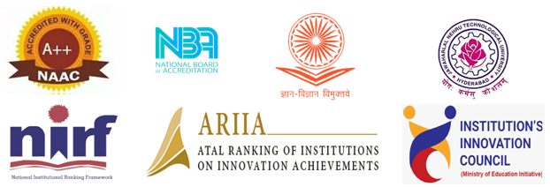
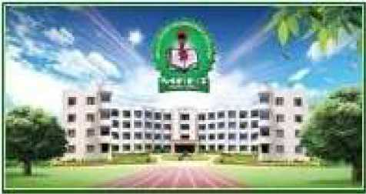
ABOUT THE INSTITUTION
Malla Reddy Engineering College (Autonomous), part of Malla Reddy Group of Institutions (MRGI), is one of the reputed engineering colleges in Hyderabad, Telangana and is founded by Sri. Ch. Malla Reddy, currently Hon’ble Minister, Labor and Employment, Factories, Women and Child Welfare and Skill Development, Govt. of Telangana State, who has invaluable insights into technical education of highest quality.

The college was established in 2002 and is an autonomous institution approved by UGC and is affiliated with JNTUH. The college has been accredited by NAAC with 'A++' Grade (3rdCycle) and The University Grants Commission (UGC) conferred ‘Autonomous’ status upon the college till the year 2024–25. Five UG programmes offered by the departments of CE, EEE, ME, ECE and CSE got accredited by NBA recently with a score of 700+ points each under Tier –I. The eligible PG programmes are also accredited by NBA till June 2022. The Institute Innovation Council (IIC) is vibrant and bagged 4-star rating. The college is listed in ‘Performer’ category in ARIIA 2021. MSME Development Institute Hyderabad sanctioned Business Incubation Center to MREC. The college received Rs. 1 Crore grant from the software giant Microsoft under the ‘AI for Earth’ scheme. In the year 2020-21, 92% of the students got placed while 94% of the students in the 2021-22 batch have been placed to date.
Organized by

Department of Mechanical Engineering
MALLA REDDY ENGINEERING COLLEGE
An UGC Autonomous Institution, Approved by AICTE & Affiliated to JNTUH, Hyderabad, Accredited by NAAC with ‘A++’ Grade (Cycle III). NIRF Rank Band 250-300, IIC 4 Star Rating, ARIIA Band Performer, NBA Tier –I Accredited (B.Tech – CE, EEE, ME, ECE & CSE, M.Tech – Structural Engg, Electrical Power Systems, Thermal Engg.)
Maisammaguda,Dhulapally(PostviaKompally),Secunderabad- 500100, Telangana, India.
Ph. No.: 040-64634231
www.mrec.ac.in

Chief Patron:
- Sri. Ch. Malla Reddy
Hon’ble Minister Labour & Employment, Factories, Women & Child welfare and Skill Development, Telangana State.
Founder Chairman, MRGI.
Guest Lecture Series
On
"Innovation trends and Startup Opportunities in Electrical Vehicles"
(30th Jan 2023)

Patrons:
- Sri. Ch. Mahender Reddy, Secretary, CMR Educational Society.
- Dr. Ch. Bhadra Reddy, President, CMR Educational Society.
- Mr. P. Praveen Reddy, Director, MRGI.

Co-Patrons:
- Dr. A. Ramaswamy Reddy, Professor &Principal, MREC (A).

Convenors:
- Dr. A. Raveendra, Professor and HOD- ME.
- Dr. S. Uday Baskar, Professor- ME., Dean Academics.

Coordinators:
- Dr.Manish Sharma, Associate Professor, ME. Email ID.: manish.mvsme@mrec.ac.in
Cell No.: + 91- 6386613473

Organizing Committee:
- Dr. N. Rishi Kanth, Professor ME
- Dr. Shaik Hussain, Professor-ME
- Dr. T Venkata Deepthi, Associate Professor-ME
- Dr. M Vijay Kumar, Associate Profesor-ME
- Mr. N Srinivasa Rajneesh, Associate Professor- ME
- Mr. V Srinivas, Associate Professor-ME
- Mr. Ch. Ashok Kumar Assistant Professor-ME

HO CAN PARTICIPATE:
Registration Form
Guest Lecture Series
On
"Innovation trends and Startup Opportunities in Electrical Vehicles"
(30th Jan 2023)

Name:_____________________

Designation:_________________

Institute: _____________________
_____________________________

City: __________________________

WhatsApp: _____________________

Email: _________________________

Sign of Participant

Principal
ABOUT THE DEPARTMENT
The Department of Mechanical Engineering has been established since the inception of the institution in the year 2002. The Department has good infrastructure facilities and is equipped with full-fledged laboratories to fulfill the curriculum needs. The Department has well experienced faculty. Around one-third of the faculty members in the department are Doctorate. The department has good number of sanctioned projects, funded by different agencies/industries. The Department is intended to be allotted a Research Centre by JNTU Hyderabad.
VISION
To be phoenix centre producing proficient mechanical engineers with ignited minds, ethical values and innovation in advanced technologies.
MISSION
• To provide solid foundation in mechanical engineering principles.
• To improve the thought process of the students and make them innovative by exposing them to advanced technologies and research.
• To produce motivated and ethical graduates and postgraduates for continuous growth in career and serving the society.

COURSE OUTCOMES
Upon completion of this course, the participants will acquire the
- Faculty Members from all AICTE Affi
- Industry Professionals

REGISTRATION FEE:
# No Registration Fee #

MAXIMUM NO. OF PARTICIPANTS:
50 No’s

MODE OF THE PLATFORM:
Virtual Sessions through ZOOM App

REGISTRATION LINK:
https://forms.gle/jVkqBziTrcdjggghn8
Note: After the registration, the link has provided for joining in WhatsApp Group.

REQUIREMENTS OF E-Certificate:

- Certificate will be given to all the participants on submission on feedback.
COURSE OBJECTIVE
The aim of this program is to provide participants with a broad exposure to recent trends and innovations in the field of automobile engineering. The Objective of this workshop is to enhance the understanding & skill set towards the automobile engineering

